Operations and Maintenance Plan
for the
Community of Selawik

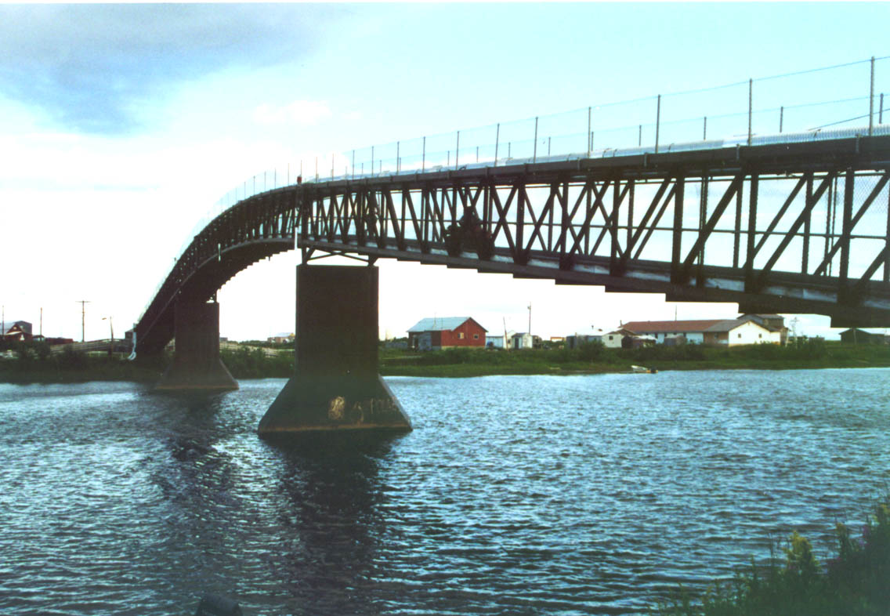

January 2003
1.0 General Facility Description
Location The site of the new solid waste disposal facility is located approximately one mile northwest of town (see accompanying design drawings).
Surface area The operational area of the landfill is located on a natural rise of about 15 feet above the surrounding tundra surface, between 15 to 25 feet above the elevation of the nearby Selawik River. The main waste disposal area is 3.5 acres, and includes the load-off pad and burnbox. The total area set aside for the facility is approximately 6 acres. A metal scrap and waste reuse salvage area, and facility transfer station, are located at the facility entrance, and take up about one acre, including traffic design and turn-around. Equipment storage, personnel shelter, miscellaneous storage, and future development of the SWM program (e.g. expanded recycling opportunities, larger waste reuse shelter, composting site, re-locating the hazardous waste storage sheds, etc.) are planned for the remaining acreage.
An additional 3 acres in the surrounding area potentially may be used for waste disposal expansion after the initial 20-year design life is spent.
Physical access A newly constructed gravel road will connect the town to the disposal facility. The road begins on the town’s northwest edge, behind the fuel storage tanks and clinic.
Public access and site containment The main disposal area will be closed off from the public. A 6 ft high chain link fence, placed on top of a 3 ft high gravel berm, will encircle this area. The salvage pad and on-site transfer station will be enclosed as well, but will be open to the public during posted hours. A minimum of 16 hours each week (at least 4 days per week, 4 hours per day) will be designated as public open hours. The exact hours for public access will be determined following a series of community comment meetings. The purpose is to maximize proper community use of the facility by setting open hours at those times most convenient to the public. Open hours will be evaluated periodically by the Environmental Department to determine whether a different schedule will should be implemented. Evaluation will be based on public feedback, operator feedback, and unauthorized dumping activity at the facility gates or elsewhere.
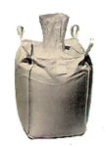
Operations and features The facility will be managed as an areafill so that wastes are placed above the ground surface, not below. A 5 ft high load-off pad extends to the center of the main disposal area for easy access. Large transport sacks (i.e. “supersacks”), shown here to the left, will be used for waste containment. These sacks are approximately 1 1/3 cubic yard in volume and 4 feet high, with an additional 2.5 ft of clearance for the purposes of folding over the top opening and securing it closed. The sacks will be stacked two sacks-high. Sacks are pre-filled at one of the six transfer stations (see waste collection section). Waste is separated at the station so that the sacks contain either burnable trash or non-burnable trash. A well-built burnbox is located at the far end of the pad. Trash that is approved for burning will be emptied from sacks and pushed into the box with a dozer.
Metal scrap and reusable wastes will be brought to the salvage pad during open hours. Fish wastes and hazardous wastes also will be brought to the facility during open hours for separate handling (see individual special waste sections for details on handling and disposal of all waste types).
Design life The facility is sized to meet the solid waste disposal needs of the community for 20 years. The use of supersacks allows great flexibility in addressing unforeseen circumstances. For example, if the waste generation is higher than expected or the facility life needs to be extended, sacks can be transported out. Also, because sacked waste is expected to decompose and reduce in volume, old sacks can be “topped off” with new wastes. Additionally, the recycling and reuse programs will be well developed over the next decade. In the future, these integrated programs will reduce waste volume by a considerable amount.
Alaska State Regulations The design, operation, and management of the Selawik Solid Waste Disposal facility will match or exceed the State of Alaska SWM regulations as codified in 18 AAC 60.
2.0 Solid Waste Management
This Chapter defines solid waste management, describes the wastestream, and identifies the handling and disposal procedures for individual waste types. The wastestream analysis in the Selawik Solid Waste Plan (i.e. “**”), referred to hereon as the Plan, is reprinted here for convenience. Additional detailed solid waste management information is contained in Chapter 2 of the Plan.
2.1 Definitions
Solid Waste All solid and semi-solid materials discarded or handled by the Selawik community for permanent disposal, recycling, reuse, or composting.
Solid Waste Management Organized handling, treatment, and disposal of Selawik’s solid wastes such that the impact of solid waste to community health, environment, and aesthetics are minimized.
Besides sound facility operation and maintenance, solid waste management carried out by Selawik includes:
- Continued development of staff SWM skills through training and education,
- Education of the community on safe and proper waste handling,
- Safe and proper waste collection program,
- Monitoring of the wastestream,
- Tracking and responding to unauthorized dumping and/or any environmental impacts,
- Evaluating the SWM program,
- Tracking logistical changes, such as barging fees, that might allow for improved methods of waste handling, and
- Developing and expanding the recycling, reuse, reduction, and composting of wastes,
- Planning for a future facility (beginning 5 years) before it is needed, and
- Sound site closure matching or exceeding ADEC regulations.
2.2 Wastestream Generation
The waste generation in Selawik is described below. Disposal patterns listed in the wastestream tables below describe the methods used previous to new facility startup.

Residential Waste The total amount of residential wastes (produced by households) is about 716 tons each year. An average of 5.1 pounds of residential waste is produced by each resident each year. See Table 2-1 for details.

Business Waste The type and amount of wastes currently generated by Selawik businesses is listed in Table 2-2. The total amount of waste generated, including what is burned, amounts to about 65 tons each year. About 15 tons of that waste, mostly cardboard and paper, is burned. These numbers translate to an average of about one-half pound of business waste (or “commercial waste”) produced for each resident, each day.

Hazardous Waste Hazardous wastes generated in Selawik are listed in Table 2-3.

Industrial Waste Industrial waste (waste produced from industrial processes) is not produced currently in Selawik, and at this time, industrial development is not planned for the future.

Total Waste The total amount of waste generated in Selawik (i.e. residential plus commercial wastes plus hazardous wastes) is about 788 tons each year. That number amounts to an average of 5.6 pounds per resident each year. This total does not include project construction wastes. Construction wastes vary each year, but can be expected to average an additional 3 to 4 percent of the wastestream, and by as much as 8 to 10 percent in a given year.

Table 2-1
Estimated current municipal solid waste generation rate and pre-facility startup disposal habits for residential sources in Selawik.
Business generator | Trash bags per week | Amount generated (tons/year)¹ | Amount taken to dump (tons/year) | Comments on disposal and burn habits
Apartments | 100 | 77 | 77 | Apartment wastes are not burned. Trash bags are collected and hauled by apartment manager. One bag per apt. every 5 days to the dump (20 apts. with 3-8 people in each apt.). The bags are generally full. The manager follows the off-boardwalk trail to the right and dumps about 10ft behind the fence, on the right-hand side of the dump. See note below on relative subsistence vs. store-bought food wastes.
Non-apartment households | 290¹  (860 equiv.)² | 642³ | 340⁴ | See Table 2-2 for dump site usage. Unlike apartment households, non-apt. households have ready access to “front yards” where subsistence preparation can be carried out. Non-apartment households therefore generate higher amounts of fish and hunting wastes, and relatively less food packaging wastes.
Total |  |  |  | Average residential waste generation for each resident: 5.1 lbs each day
1 Number of trash bags actually produced, taking into account estimated burned household trash.
2 Number of trash bags that would be produced without household barrel burning. Useful for structuring a waste collection system, with banned burning.
3 A waste characterization study did not produce significant results due to lack of participation. Therefore, waste generation is based on apartment resident per capita waste generation, a known quantity.
4 Amount of wastes actually taken to dump, taking into account burned wastes and the estimated 10 percent of wastes taken to the boat dump.
Table 2-2
Estimated current municipal solid waste generation rates and types and pre-facility startup disposal habits from businesses in Selawik.
Business generator | Trash bags per week | Amount generated (tons/year)¹ | Amount taken to dump (tons/year) | Waste type | Comments on current disposal and burn habits
McCoy's Store | 4.3 | 3.6 | 2.2 | Wrappings, plastic and cans, coffee Styrofoam cups | They burn all cardboard in-town. They order 2,400 cans of soda/month.
Water Plant/ Washeteria | 4.3 | 3.3 | 2.8 | Mostly paper. They try to recycle packaging material.
School (when in session) | 52.8 | 42.7 | 42.7 | Food, paper, napkins and only a small amount of plastic | They burn at the dump everyday. School is in session Aug 23-May Monday-Friday. Little waste is generated off-session (May - Aug 23), except cardboard boxes from new supply orders.
Power Plant | 0.3 | 0.3 | 0.2 | Wiring, cans and old pipes (to dump), oil rags and paper (incinerate) | The Plant uses a smart ash burner (in-town) for oil rags and all paper.
Rotmans Store | 5.0 | 3.9 | 0.5 | Cardboard, outdated food, paper | Rotmans' burns trash twice per week, mostly cardboard. Trash taken to the dump about 4 times during the summer and 6-7 times during the winter (amount increases in the winter due to holidays).
Native Store | 8.7 | 6.7 | 1.3 | Paper receipts, coffee filters, cardboard, strapping tape, outdated food, etc. | All garbage is burned. Once per week they go to the dump and take ash and cans that didn't burn, as well as outdated food. Also 3-4 honeybucket bags/ month. They order 120 boxes of food/week.
DJ's | 1.0 | 0.8 | 0.0 | Same | DJ's burns everything, including plastics. They take personal honeybuckets and ashes to the dump twice a year. They make cardboard logs with the cardboard.
Post Office | 3.3 | 2.6 | 0.0 | Paper, cardboard | Burn all wastes - nothing is left over to bring to dump.
Clinic | 1.5 | 1.2 | 0.1 | Paper, cardboard, med waste (gauze, etc.) | Only the soda cans from staff lunches go to the dump. A maintenance worker burns everything else after 4pm each. Sharps go to Kotzebue.
Total | 81 | 65 | 50 | Average business waste generation for each resident: ½ lb each day

Table 2-3
Annual hazardous current waste generation, storage, and pre-facility startup disposal habits, estimated from a Summer 2000 waste survey.
Generator | Hazardous materials reported | Maximum amount used or stored yearly | Comments | Estimated amount discarded after use, yearly
AVEC | Motor oil, antifreeze, cleaning solvent | Motor oil: 880 gal/yr Antifreeze: 165 gal/yr Cleaning solvent: 12 gal  Bulk fuel: 130,500 gal | Amount of cleaning solvent listed lasts well over one year, and is not ordered on a yearly basis. | Based on incoming shipments, an estimated 400 - 800 gal/yr of motor oil are discarded or burned at the dump. An estimated 40 - 130 gal of antifreeze are discarded at the dump. It is unclear whether used antifreeze is poured out on ground in town, or at dump.
Clinic | Antifreeze | Antifreeze: 2,200 gal | Antifreeze stockpiled to last several years-- not ordered on a yearly basis. | It is unclear how frequently antifreeze is replaced at the clinic.
Fuel Head | Fuel oil | Diesel stored: 115,000 gal/yr, tank capacity = 167,000 gal | They barge in a yearly shipment of 115,000 gallons of fuel. | Diesel is burned in engines, emissions are airborne. No fuel containers are dumped because fuel is pumped into tanks.
Water Plant | Calcium hyperchlorate, Fluoride | CaClO₄ 0.4 tons/yr Fluoride 0.05 tons/yr | All of the empty bags and containers go to the dump. | Calcium Hyperchlorate is completely used up each year. Fluoride is stored until used up.
School | Bulk fuel | Tank cap. = 141,000 gal | School maintains separate fuel supply. | Small amount. Fuel spills/leaks onto ground while pumping are relatively common.
Town population (including homes and businesses) | Reported: diesel, lead-acid batteries¹.  Unreported: Vehicle antifreeze, paints, fluorescent light bulbs, small batteries, household cleaning products, motor lubricants, thermometers | Diesel used: 115,000 gal/yr (from IRA Fuel Head), plus Rotmans Stores have a fuel tank capacity = 130,079 gal  Lead-acid batteries: approx. 200 batteries are in use.  Motor oil:150 to 300 gal in use. | Rotmans Stores maintain separate fuel supply. Usage information unavailable. | Motor oil: Assuming 200 snowmachines, hondas, and boats used in Selawik, approx. 50 - 100 gal/year of motor oil are discarded on the ground (at dump or in-town). An additional 30 - 100 gal leak into ground or river during vehicle operation.  Batteries: Assuming a 5 yr life, approx. 40 lead-acid batteries, containing approx. 360 lbs of lead, are discarded on the ground.  Other household hazardous wastes: Approximately 0.6 tons per year.
¹ Residents were questioned in an informal survey to gauge community awareness of household hazardous wastes.
2.3 Waste Collection
Five transfer stations in-town and one transfer station at the inside entrance to the facility will be operated. Residents will bring their waste to the transfer station for collection.
Station design Each in-town transfer station will consist of a basic open 3-sided shelter with three to six sack holders, three to six sacks, and one recycling bin. These stations are designed to be light and simply-constructed for maximum mobility and configuration flexibility, as well as minimum cost and maintenance. They can be moved should relocation to a more efficient location be desirable. Note, station fencing is not expected to be needed because 1) the sacks will offer plenty of disposal space, 2) due to sack configuration, the flying out of wastes is unlikely even if left unclosed, and 3) Selawik is a small community where residents are respectful of each other.
Facility transfer station The station at the disposal facility will be similar to the in-town stations, and include large covered totes (i.e. “fish totes”) for subsistence wastes, lead-acid batteries, containerized used oil, and miscellaneous hazardous wastes (two totes). The facility transfer station is open only during staffed hours so that disposal into these special waste totes is supervised. See Sections 2.4 and 3.8 for further details on waste handling, storage, and disposal.
Station size and sack type Burnable waste generally comprises over two-thirds of municipal solid waste volume. Therefore, at least two sacks will be available for burnable wastes and one sack for non-burnable waste at each station. The composition and amount of incoming waste is expected to vary at each station. Therefore, the exact number and sack type will be set according to the identified need for each station location.
In-town access Stations will be unlocked and ungated so that residents will have convenient access at all times. A locked station would encourage unauthorized dumping outside of the sacks or unsightly and unsafe waste storage in house yards. Worse, locked stations could encourage renewed dumping at the old municipal dump and the closed “boat dump” on the banks of the Selawik River.
Schedule and route design Assuming 90 percent of the residential wastestream is discarded at the five in-town stations, about 84 yds of waste, filling about 80 sacks, will be collected each week. This calculation assumes that the average sack will be filled at about 300 lb per cubic yards, to about 75 percent of its volume capacity (and less than 10 percent of its weight capacity). Assuming equal station usage, each station will require pickup five times per week (i.e. a total of 16 sacks each day, 3-4 sacks per station), but the collection schedule will be adjusted as the attendant needs at each station become apparent. Optimum travel-time logistics will also be determined. For example, the collection technicians may realize a reduction in required route time by servicing each station twice weekly (with a larger number of sacks left at each station). Pairing up station collections (e.g. scheduling collection for the two northernmost stations on the same day) also may prove to be more efficient, once community station disposal behavior is identified in detail.
Location and signage Initially, based on the geographic spread of households in Selawik, stations will be sited as depicted in Figure 2-1. Stations will be moved should more desirable/efficient station locations be identified during the course of operation. Additional stations will be added as needed in the future. Durable signs at each station will be placed that detail authorized wastes and proper station use. Additionally, a board for posting notices to the public (e.g. noting improper station use, etc.) is included at each station.

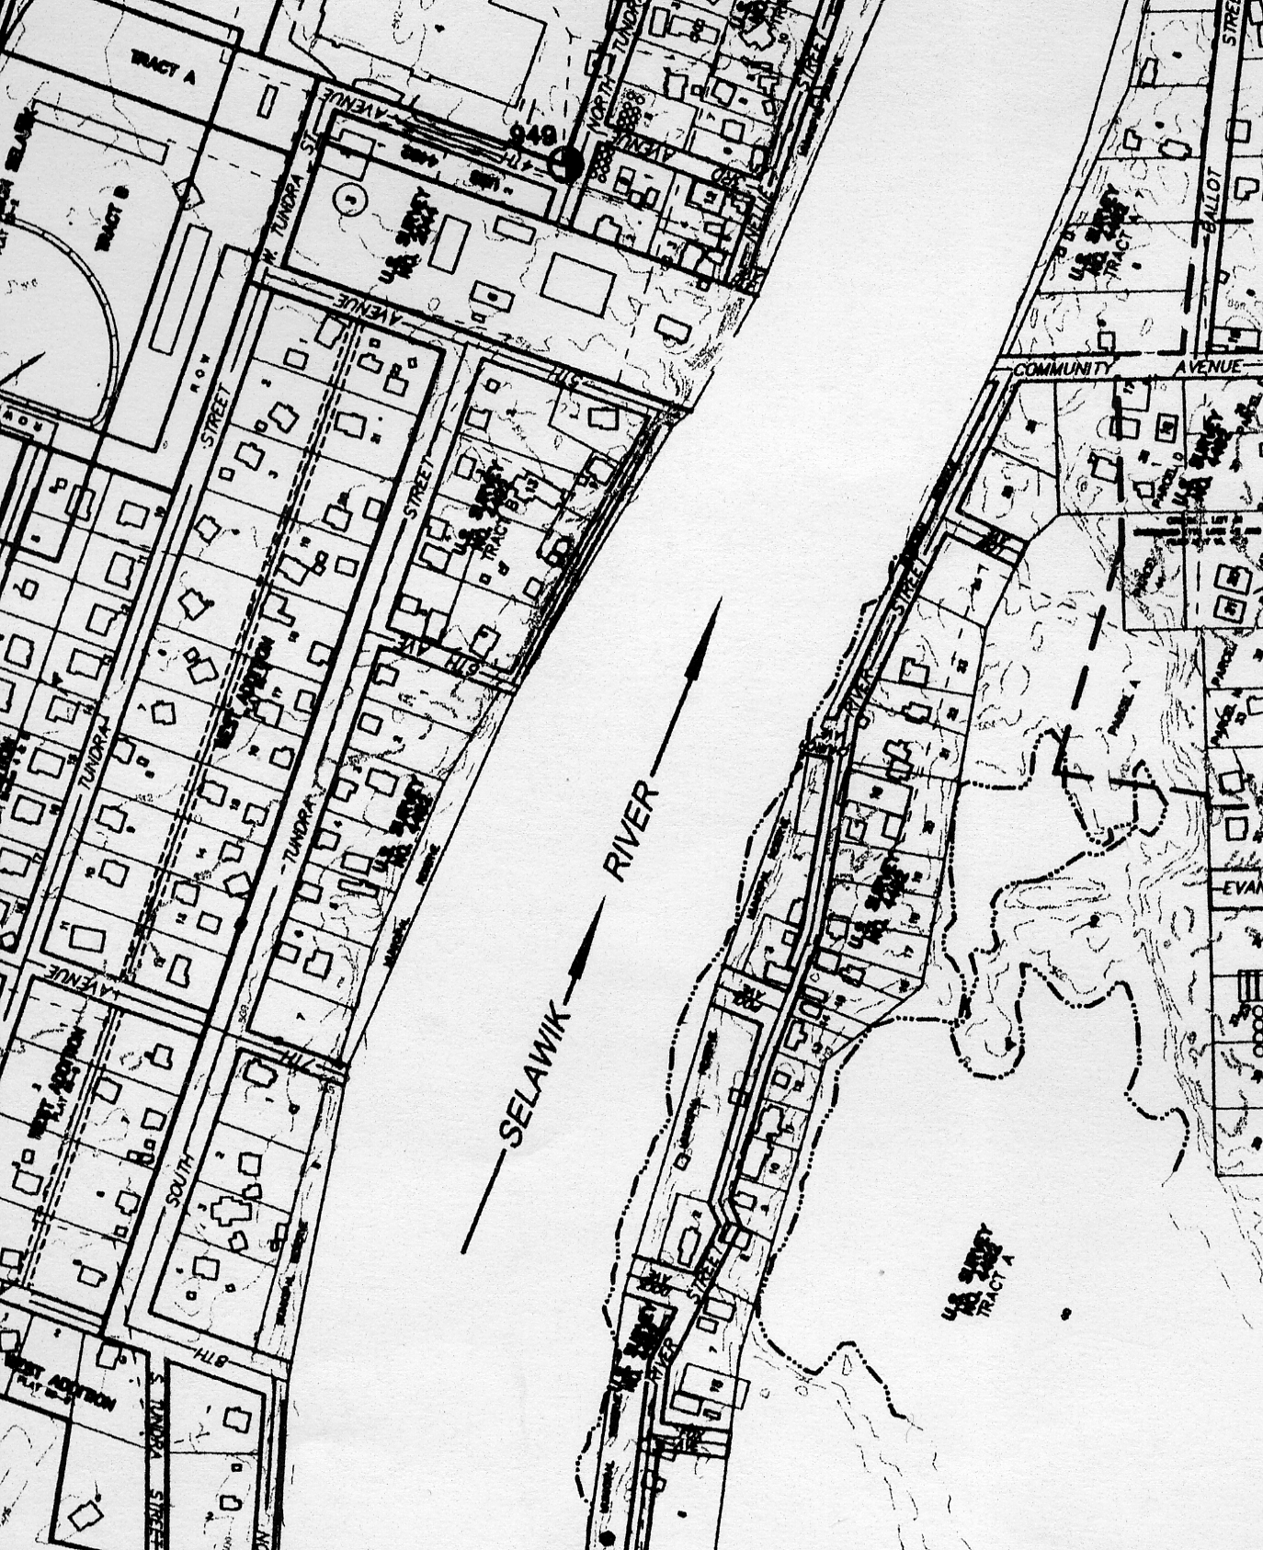

Figure 2-1 Initial location of in-town transfer stations. (Stations are denoted with a .
Hauling Sacks will be hauled in-town by ATV-pulled trash carts. Each of the carts will hold two full sacks. The Collection technician will perform maintenance (i.e. cleanup) at the stations as needed, post notes to the station’s users as necessary, and replace the collected sacks with empty ones. Sacks will be collected with use of a hydraulic jack (carried in the cart). One side of the cart will be removable to ease loading and unloading. For time efficiency, the carts will be driven to the beginning of the facility road, hooked up as a “train” to a heavy duty pickup truck, then hauled to the facility.
2.4 Wastestream Handling and Disposal
Authorized disposal and handling methods for the various types of wastes identified in the Selawik wastestream are described below.
2.4.1 Refuse
Refuse is the general garbage, rubbish, and trash that comprises the bulk of solid wastes generated by residential and commercial (businesses) sources. For the purposes here, refuse excludes hazardous wastes other than residual household hazardous waste that remains in the container following complete use of the product as intended. Refuse that is small enough to fit in the supersacks located at the six transfer stations will be discarded by residents into the appropriate sack, and transferred to the disposal facility. Burnable refuse will be taken to the burnbox for burning (see operations section for procedure details). Sacked non-burnable wastes will be taken directly to the active areafill waste cell for placement. Larger burnables (e.g. pallets, poor condition furniture) will be brought to the facility transfer station by residents and transferred to the burnbox by staff. Larger non-burnable items will be brought to the salvage pad. Larger non-burnable items (e.g. white goods) are generally reusable or recyclable (as metal scrap). Items that are neither reusable or recyclable will be taken apart and placed in sacks or discarded on top of the first sack lift. This method will not threaten the environment because larger non-burnable items are not putrescible and do not attract disease vectors. Additionally, the underlying sacks provide a liner as well as insulation.
2.4.2 Ashes
Currently, 65 percent of residents burn their wastes in-town. As identified in the SWM plan, this method seriously threatens community health, and will be phased out. All burning will be carried out at the burnbox. Ashes from the burnbox either will be sacked and placed in a separate area of the active waste cell or, in the case of ashes from a complete burn, used as intermediate cover when needed. Ashes have been re-used as waste cover, road and foundation fill, and compost amendment in some Outside communities. As the Selawik SWM program develops, a useful purpose for the sacked ash from incomplete burns may be identified. Before using ashes for intermediate cover, testing for contaminants will be carried out, and the procedure will be thoroughly investigated and supervised. It should be noted that because ash will be placed on top of heavy, impermeable sacks, use of ash as cover is an ash disposal method that results in greater environmental protection than a permitted monofill. Ash particulate that is temporarily released to the air during placement will not present a health hazard to the public because the public is not allowed in the area.
2.4.3 Demolition and Construction Waste
Wastes resulting from construction and demolition projects includes dirt, stones, concrete, cement, bricks, plaster, lumber, shingles and plumbing, heating, and electrical parts. Much of this material could be re-used in Selawik. Significant volume construction wastes generated by residents (i.e. house remodeling, etc.) will be brought by the resident to the salvage pad, separated into reusable, burnable, and non-burnable/non reusable, and discarded accordingly.
Disposal of construction and demolition wastes from contracted projects will be regulated by the City and IRA of Selawik. Before project startup, contractors must submit a waste disposal plan to the supervising local government that oversees the project. The plan must include time schedule for waste generation, an estimate of the type and amount of wastes expected, and the proposed procedure for disposal. Any hazardous wastes must be shipped out at the contractor’s expense. Other wastes can be discarded at the facility, stored for salvage and re-use, or shipped out. The Selawik IRA Environmental Department (as managers of the SWM program) must approve the plan and monitor project compliance. Wastes that are discarded at the facility will be subject to a per volume fee commensurate with the proportionate cost incurred for proper site closure, shortened facility life span, and staff monitoring time. Reusable wastes will be charged on a sliding scale basis, depending on their relative value to the community.
2.4.4 Animal Carcasses and Fish Waste
Animal carcasses (including dogs and other pets) and high-volume fish wastes will be self-hauled to the facility during open hours. Residents will arrange with the facility technician either to deposit their wastes in the designated tote at the facility transfer station, or be escorted to the burnbox to deposit their wastes in, or adjacent to the unit. Because of the higher risk for disease transmission, deceased pets will be hauled immediately to the burnbox unit, which is off-limits to the public. During closed hours, residents may arrange to meet the staff at the facility entrance to transfer deceased pets. Pets will be incinerated within 24 hours of disposal. Subsistence/food preparation wastes in a volume consistent with daily or weekly meal preparation may be discarded at the in-town transfer station in a sack designated for burnables. If the collection schedule develops so that a station is serviced less than 2 times per week, fish wastes may be banned from that station to avoid heavy putrescence.
2.4.5 Honeybucket Waste and Miscellaneous Septage Wastes
Less than 15 households are not hooked up to the sewer line. Wastewater from all other households is piped directly to the sewage treatment lagoon. Honeybucket wastes will not be allowed at the disposal facility, so that their regulation is not under the purview of local, state, or federal solid waste regulations and guidelines. Guidelines, education, and enforcement for honeybucket waste handling and disposal are under the purview of the Selawik IRA, and are managed elsewhere. Currently, there is no other type of septage waste generated in Selawik. If other septage sources are developed in the future (e.g. tank sludge from tourism facilities, compost toilets, dredged sludge from lagoon), these wastes will be prohibited at the disposal facility. A site specific waiver may be granted if such disposal is proven to be beneficial to the community and such disposal is demonstrated to not harm the environment in a significant way. In particular, compost from any composting toilets used in the future may be accepted.
2.4.6 Medical Waste
Medical wastes are prohibited at the landfill. All sharps are shipped from the clinic directly to Kotzebue for proper disposal. Gauze, bandages, and other contaminated medical wastes are burned daily, after public hours, at a designated barrel adjacent to the clinic. The barrel is perforated for efficient drafting. The clinic staff ensures that the burn is complete and covers the barrel before leaving. Accumulated ash is taken to the disposal facility as needed. Used syringes from household personal use (e.g. diabetic syringes) are brought to the clinic by residents.
2.4.7 Vehicles and Equipment
Vehicles and mechanical equipment may be junked at the salvage pad. All batteries must be removed at, or prior to arriving to, the facility. All fluids must be drained properly before leaving the facility. Vehicles and machinery cannot be used for erosion control unless used in such a manner that is demonstrated to not threaten the environment in any significant way, or is demonstrated to be the only cost-feasible erosion control action, and inaction is expected to result in a more serious environmental threat. Other use of vehicles or equipment will be approved by the Environmental Department only in the case that such use is demonstrated to result in equal or lesser overall environmental impact than the potential impact caused by their long-term storage at the salvage pad.
2.4.8 Salvageable and Recyclable Materials
Salvageable items include furniture, vehicles, vehicle parts, some construction wastes, toys, small appliances, and white goods (i.e. large appliances). These items will be self-hauled to the salvage pad. A pre-fabricated shed or shipping container will be sited at the salvage pad to house reusable items that cannot be exposed to the elements. Such items include clothes, rugs, books, computers, and some furniture, toys, and small appliances. Tarps will be used to cover large appliances outside that are in good condition and likely to be reused by residents.
The salvage yard will be cleaned and organized at least annually. At that time, items that have lost salvage value will be segregated into metal scrap and non-recyclables. Non-recyclables will be integrated into the areafill as described above for large non-burnable refuse. Refrigerators and freezers will be backhauled for metal scrap and drained of freon by certified technician prior to transport or long-term storage in Selawik. Older refrigeration units (i.e. from the 1970’s and earlier) containing PCBs will be backhauled, or dismantled to remove PCB-containing parts for treatment as a hazardous waste.
Aluminum cans and other aluminum items are recycled through the ALPAR program. These items will be discarded at the recycling bins located at the six transfer stations. Lead-acid batteries will be self-hauled by residents to a covered tote at the facility transfer station, and barged out for recycling in the Lower-48.
2.4.9 Computers
Computers contain high amounts of lead, as well as a number of other heavy metals. Therefore, computers are prohibited at the areafill and transfer stations. Working computers will be accepted at the salvage area covered shed, on a space available basis. The school, IRA, and City offices will be required to develop a computer disposal plan. Such a plan can include community donations or sales, backhaul for recycle, or long-term storage. Residents are encouraged to bring their old computers to Anchorage for part-reuse by a computer shop or disposal at the Class 1 landfill. The computer disposal policy will be reviewed every five years to reflect changes in computer components or backhaul/recycling cost logistics.
2.4.10 Liquid Waste
Liquid wastes are prohibited at the areafill and at the transfer stations except in containers of less than one gallon. To discourage abuse of this policy, containerized liquid wastes are limited to one gallon per household per week. Hazardous containerized wastes are prohibited.
2.4.11 Hazardous Waste
Hazardous wastes are materials that pose a health and safety threat to human, plant, or animal life. These wastes are prohibited from disposal at the landfill. Hazardous wastes can be grouped into the following categories: 1) flammable, 2) explosive, 3) radioactive, 4) chemical, and 5) biological, which exhibit any one of the following characteristics: 1) ignitability, 2) corrosivity, 3) reactivity, or 4) toxicity. Some examples of common hazardous wastes are:
- Lead-acid batteries (these are collected at the facility transfer station)
- Transformers or other objects containing PCBs (such as some older refrigerators which will be dealt with according to Section 2.4.8 above)
- Regulated Asbestos Containing Material (RACM)
- Used oil
- Antifreeze
- Paints, varnish and stripper
- Motor oil
- Many boat/vehicle/house maintenance products
- Many household cleaning products
Residual hazardous waste Note hazardous waste containers with residual quantities of hazardous waste remaining (i.e. emptied and rinsed containers) are acceptable at the transfer stations and areafill.
Program description The Selawik IRA manages two 20 ft. shipping containers that have been retrofitted to store hazardous wastes prior to backhauling. These containers are located on the barge landing road, about one mile from the disposal facility. One day per week (exact hours to be set according to public opinion voiced at community meetings), household hazardous wastes will be accepted at the disposal facility for segregation and transport by staff to the hazardous waste storage containers. These wastes will be placed into large totes. HAZMAT/HAZWOPPER certified staff wearing protective gear will closely supervise the drop-off of hazardous wastes to ensure that non-mixable materials are not placed in the same tote, container tops are secure, and materials are handled properly. Hazardous wastes that can be safely discarded at home by following printed instructions on the container may be sent back with the resident.
Reusable hazardous wastes Reusable hazardous wastes can be safely stored arranged at the salvage yard for residential pickup and exchange. Such waste would include paints, cleaners, strippers, varnish, etc. in non-damaged and sturdy containers. These products would be covered with tarps during closed hours or placed in the reuse shed if deemed safe to do so by trained staff.
Used oil Used oil will be accepted at the facility transfer station. Oil must be contained in a sturdy, capped container. The used oil will be transferred to the IRA’s used oil burner that will be operated by trained IRA and city employees to heat the IRA/City workshop. Excess oil will be stored in a hazardous waste storage shed.
Lead-acid batteries Lead-acid batteries will be collected at the facility transfer station in a designated tote. These totes are approved for shipping unbroken batteries via barge. The Selawik SWM program will arrange for free-of-charge battery backhauling to an Anchorage Battery Store. The Store will ship the batteries to Seattle for recycle.
Commercial hazardous waste commercial hazardous waste in quantities over that expected from a residential household, will not be accepted. Businesses must arrange for backhauling or proper disposal elsewhere. Businesses and projects will be required to submit a hazardous waste plan that lists the amount and type of waste expected each year or per project, along with the planned disposal method. Local businesses may be able to store small quantities of hazardous wastes at the IRA storage sheds and may be charged a storage fee.
Shipment and storage capacity The Environmental Department will track, plan for, and arrange, hazardous waste shipment and/or additional storage (depending on cost logistics) as needed.
Program development The goal of the Selawik hazardous waste program is to educate the community and manage the wastestream such that hazardous wastes are not generated or they are completely re-used, or they are backhauled by businesses for recycle or disposal. See Education Program Section and Waste Recycling, Reuse, and Reduction goals for further details on the hazardous waste program.
3.0 Facility Operations Plan
Details on daily operation and maintenance of the areafill, burnbox, facility transfer station, in-town transfer stations, and salvage pad are described below.
3.1 Public Access
Public access to the facility is allowed only during open hours and only at the facility transfer station, salvage pad, and reuse shed. These features are enclosed by a gated fence during closed hours. A second gated fence separates this area from the areafill and burnbox. Selawik is a close-knit traditional community and values its traditional lifestyle and culture. Open hours will be determined by public consensus at the initial community meetings that will be held before facility startup. A minimum of 16 hours per week will be designated for public access, with a minimum of 4 days per week, including one weekend day. Open hours will be reviewed periodically to ensure schedule optimality. Additionally, open hours will also conform as needed to the traditional schedule the community follows, as determined by subsistence practices, community events, community mourning periods, and community emergencies. An increase or occasional small decrease in open hours will be authorized should the need be identified. Exceptions to public access rules are granted for residents arranging with the SWM staff in advance for the purposes of hauling special wastes to the areafill or burnbox. In these cases, staff will escort residents.
3.2 Animals, Birds, and Insect Vector Minimization at the Areafill
Animals, birds, and insect vectors are not expected to present a problem for the following reasons:
- The areafill is fenced off
- The wastes are fully enclosed in heavy sacks
- Bears are not present in the Selawik area
- Putrescible wastes are contained in the burnbox and are reduced to ash within 24 hours, so that attractive odor is minimized and a food source is absent.
- It should be noted that even at the old landfill, birds and animals were not present in noticeable numbers. It is postulated that the Selawik Wildlife Refuge offers abundant alternative food sources away from human contact and environmental contamination. The new facility is located in an adjacent area to the old facility. Given the additions of waste containment and operational control, the new facility is not expected to be a significant attractant for birds and animals either.
Therefore, the sacks placed in the areafill are expected to remain undisturbed. Birds are not expected to present an aviation problem, and insects are not expected to present a heightened disease transmission problem.
3.3 Prohibited Wastes
This section defines waste types which have restricted or prohibited disposal directives. See also individual waste types listed in Section 2.4 for details on waste handling and rule exceptions.
3.3.1 Wastes Prohibited Facility-Wide
Hazardous wastes are prohibited at the facility, except for the purposes of authorized hauling, storage or reuse as described above. Burning of hazardous wastes is not allowed.
3.3.2 Burnbox Waste Requirements
Discarding wastes into transfer station sacks that are designated for burning is prohibited except when discarding the following:
- Paper wastes (except those used for cleanup of hazardous substances, or otherwise significantly contaminated with hazardous wastes)
- Cardboard (same exceptions as for paper wastes)
- Food wastes (excluding volumes inconsistent with daily food preparation which must be handled as described above before eventual incineration)
- Lumber and wood scrap (except in volume or size that would consume an unreasonable amount of sack capacity.
- Clothing (except that unduly contaminated from hazardous substances)
- Small rugs and miscellaneous textiles (Large rugs and carpets will be accepted at the facility for use in areafill cover or for burning. Note the chemical level in chemical-treated textiles decreases over time and is very low in older items that would typically be discarded. Newer rugs/carpets/other would be stored in the reuse shed.)
- Small furniture (Any item consuming an unreasonable amount of sack capacity will be accepted at the facility and transferred to the salvage pad/reuse shed, or burnbox as condition warrants.
3.4 Areafill Operation
The areafill is not open to the public. Thus, operation procedures will be carried out by SWM staff in the absence of the public endangerment typically associated with landfill operations (i.e. injury from falls, by sharp objects, equipment accidents or disease transmission). Procedures are as follows:
- Sacks will be driven inside the inner fence by the collection technician.
- Sacks containing burnable wastes will be unloaded and emptied in the burnbox, and burned (see below for burnbox operation details).
- Sacks of ashes and sacks of non-burnables will be placed on the loading ramp.
- The operator will tamp down uneven sacks as needed with use of a plywood board placed on top of the sack, pressing it down manually or by forklift. Sacks will be checked to ensure proper sack closure.
- Sacks ready for placement will be moved by the operator by Bobcat forklift to the active area of the areafill and placed.
- Placement will begin against the back berm and proceed inward. The areafill will be filled counterclockwise, arc section by arc section, rather than successional semi-circles that move in one row at a time. The sacks will be stacked two-high. Due to logistical considerations, the placement of the top lift will proceed concurrently with placement of the bottom lift. Thus, the operator will place two adjacent bottom rows for stability, and then place a top row, slightly inset from the bottom row edge. A bottom row is placed next, then a top row, then a bottom again, then a top, etc.
- To avoid sack degradation by UV light, the top row of sacks will covered within 1 year by a tarp, 3 to 6 in of soil or gravel, ash (if determined to be safe to do so), crushed glass, discarded carpet, or a combination.
3.5 Burnbox Operation
The burnbox will be of similar design as that used in Togiak, Alaska, as depicted in Figure 3-1a 3-1b. The unit is designed so that heavy equipment drive through to push waste in and push ash out. The Selawik unit will be sized for the John Deere 550 G dozer that the IRA owns, and will be located at the far end of the load-off platform at the areafill. The location is designed to conform with prevailing wind direction, as specified in the Selawik Solid Waste Plan.
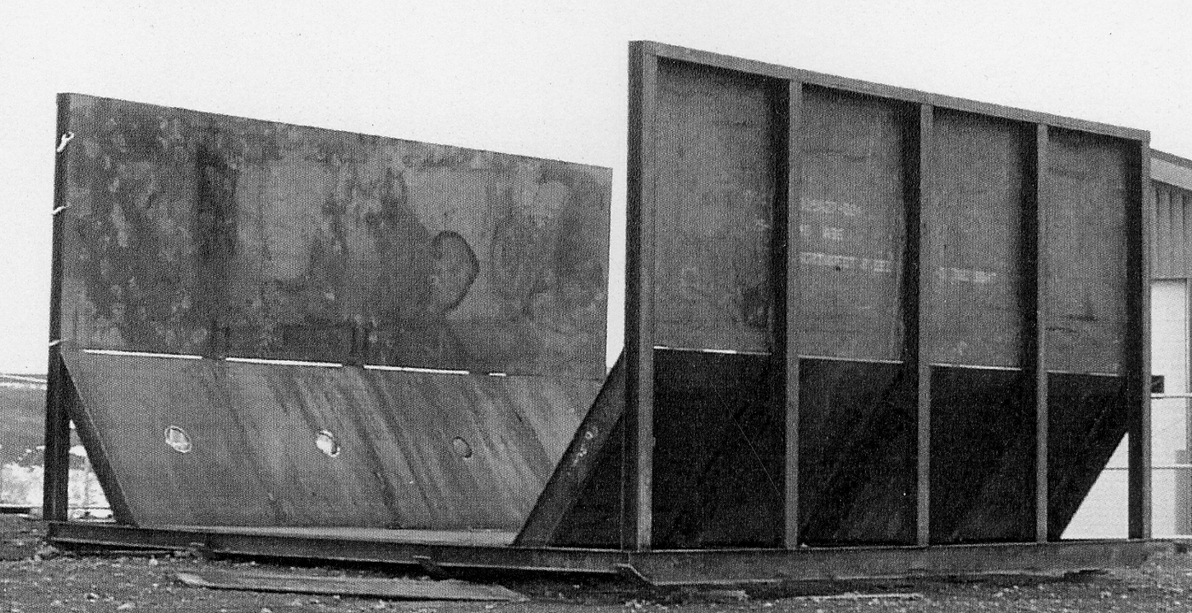
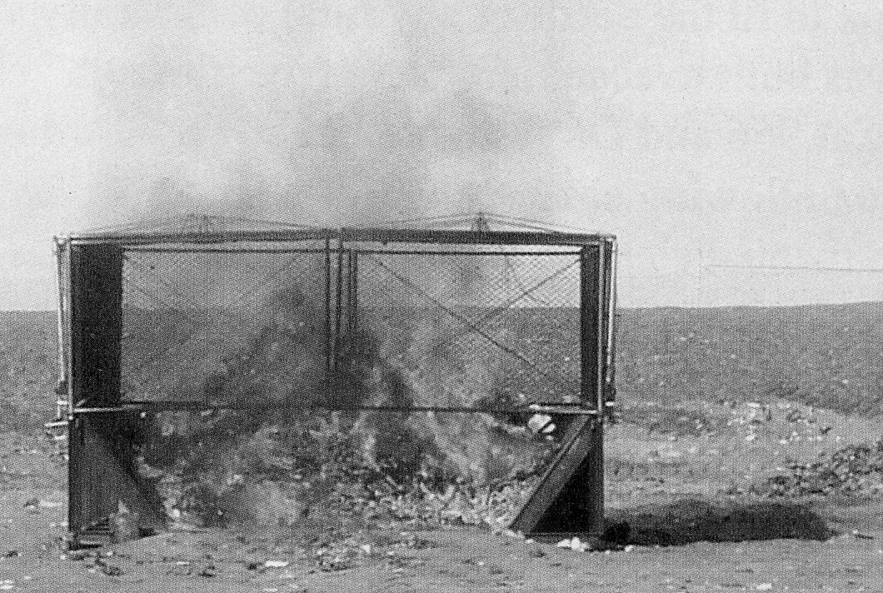
Figure 3-1a-b. Togiak Burncage (courtesy Summit Engineering, Tok Alaska)
3.5.1 General Operation
Several covered heavy-duty totes (i.e. “fish totes”) will be stationed next to the burnbox to facilitate any needed waste separation or storage. Wastes will be driven into the burnbox by the cart, unloaded, and emptied. A portion of the bagged cardboard and paper from the stores, tribal office, and school is set aside to store for use as an amendment to the residential wastes, and animal and fish wastes, when needed to achieve a lower moisture content.
3.5.2 Waste separation
Operator technicians, wearing protective gear, will sort through the contents with rakes to pick out prohibited wastes, or wastes that are inappropriate for burning. At that time, an attempt will be made by the operator to identify the household that discarded said waste item(s). Often, household wastes will be accompanied by envelopes, papers, etc. that identify the generator. The operator will note the transfer station of origin so that the collection technician can post a warning or educational notice.
Pulled out wastes that are prohibited (see Section 3.3) will be placed in a covered tote and transferred to the appropriate destination. Wastes that are suitable for the areafill as non-burnable waste will be loaded into a sack for placement into the areafill.
3.5.3 Waste moisture control
To match or exceed State opacity requirements (to not exceed 20% opacity for over three minutes in any one hour), the waste moisture content should be minimized. Selawik is located in an arid tundra environment. The average ambient waste moisture content is low, likely less than 25 %. Precipitation does not come into contact with wastes once they are discarded at the transfer stations because the sacks are closed. Wastes are not emptied from the sacks until burn time.
In the case of a waste load that has an atypically high–moisture content, the load will be mixed with a higher volume of cardboard and office paper from the school, stores, and tribal offices that has been set aside for this purpose.
3.5.4 Waste burning
A strict procedure for operating the burnbox will be followed. Because the City of Togiak has achieved excellent results with their burnbox, the operational procedures there will be used as a basis for the operations in Selawik. Advice will be sought with the Togiak Burnbox Operator.
High temperature A higher temperature burn results in a more thorough incineration of wastes and a reduction in smoke toxicity. The burn temperature will be maximized through minimization of moisture content (see 3.5.3), separation of non-combustibles from the burn unit waste stream (in both pre-collection and post-collection phases), and an efficient quick startup of the burn will be accomplished by first lighting dry, clean combustibles (i.e. cardboard and paper) set aside for the purpose.
Public access The public is not allowed at the burnbox except when escorted by SWM staff for the purpose of hauling special wastes to the area (e.g. animal carcasses, old poor-condition furniture).
Wind direction and speed In the event of a wind direction towards town and a wind speed greater than 15 miles per hour, or a wind speed in any direction that is considered unsafe, burning will be delayed until conditions improve. Because wastes are contained in supersacks, accumulation of several days worth of waste will not present a significant health threat. See the SWM Plan for a wind analysis for Selawik. Note with the designed location, the wind direction will be directly towards town only occasionally, rarely sustain for more than 3 days.
3.5.5 Protective gear
Staff must wear appropriate protective gear at all times when operating the burnbox before, during, and after the waste burning procedure. Gear includes Tyvek suit, steel-toed boots, and a mask to filter smoke as well as ash particulates that are likely to be contained in the air both before and after the burn.
3.5.6 Ash handling
The Burnbox Operator will spread the ash out with a dozer to allow for effective ash cooling. After the ash is fully cooled, the ash will be inspected to ensure that a full waste burn has been accomplished. After 3 days (to remove the danger of flare-up), ash from a poor burn will be loaded into a sack and placed in the areafill. Ash from a successful burn will be taken out to the areafill to apply as intermediate cover, to store for future cover, or to fill in potholes or ruts as appropriate. Any inappropriate unburned wastes (e.g. metal cans that may puncture sacks) will be removed before applying the ash.
3.5.7 Burnbox maintenance
The burnbox selected by Selawik requires little maintenance. The only moving parts are the side doors of the cage that drop down to form ramps for the dozer. The unit will be kept clean, and the moving hinges will be kept well lubed and free of grime. To prevent unsafe working conditions, the area surrounding the burnbox will be kept free of litter, and ruts and potholes will be filled in as they form.
3.6 Salvage Pad
The salvage pad will be open to the public only during facility open hours. Wastes will be self-hauled by residents and unloaded at the spot designated by the attending staff person. Wastes will be broadly sorted into vehicles and vehicle parts (including tires), equipment and appliances, furniture, toys, construction materials, and afely-contained reusable hazardous materials, such as paints, that do not pose an ignition or reactive risk. A pre-fabricated waste reuse shed will house priority items that should be sheltered, such as clothes, some toys, books, computers, small appliances, rugs, some furniture. During closed hours, hazardous materials will be brought into the shed or covered with a tarp (top and bottom) to protect containers from the weather.
3.6.1 Sales
Items of obvious and immediate resale value may be affixed a price by staff. All revenue is recorded and deposited into the SWM program account. Disputes must be handled at the IRA, and not at the facility.
3.6.2 Litter
The Salvage pad and shed will be regularly cleaned of litter by the facility staff.
3.6.3 Access
A clear and safe path for salvaging materials will be maintained. If at anytime the attending staff person deems access to a particular waste item or area unsafe, the staff person will either escort the salvager to the area, move the item to a more accessible location, or prohibit access to the problem area until access is safe, as decided by the staff person.
3.6.4 Refusal of entry
The staff person has the right to refuse persons salvage access if they deem the safety of the person is at risk by their behavior (under the influence or “horseplay”), attire (open toed shoes), or age (under 6 if accompanied by an adult, under 13 if unaccompanied
3.6.5 Annual Organization
The salvage yard will be fully cleaned and organized at least annually. At that time, items that have lost salvage value will be segregated into metal scrap and non-recyclables. Non-recyclables will be integrated into the areafill as described above for large non-burnable refuse.
3.6.6 Refrigeration Units
Refrigerators and freezers will be backhauled for metal scrap and drained of freon by certified technician prior to transport or long-term storage in Selawik. Older refrigeration units (i.e. from the 1970’s and earlier) containing PCBs will be backhauled, or dismantled to remove PCB-containing parts for treatment as a hazardous waste.
3.6.7 Other wastes
The subsections of Section 2.4, describing the handling of other salvage pad wastes, such as vehicles, vehicle parts, and computers provide additional salvage pad operational guidance that should be adhered to.
3.7 In-Town Transfer Stations
As described above in Section 2.3, the in-town transfer stations will consist of 3 to 6 sacks and one recycling bin for aluminum. The collection schedule will be optimized according to actual community use. The Collection Technician will be responsible for identifying the optimum route and schedule, and after the initial startup, will review the route and schedule at least every six months. Each station will be collected from at least once per week, and depending on station use, up to 5 times per week.
It will be the Technicians responsibility to:
- Notice disposal behavior at each station
- Post temporary public education notices on unauthorized or improper use of individual stations, changed facility open hours, or other SWM issues useful to the public.
- Notify the Environmental Department of any serious violations. (Note, the Selawik Emergency Response policy requires that the Environmental Department be notified immediately in the advent of a spill of unknown nature,.)
- Keep each station litter-free.
- Replace sacks with empty sacks.
- Note any station features that may require attention. Make minor modifications to the station design/configuration or trash cart as appropriate.
- Record the number, type (i.e. burnable or not), and relative fullness of sacks collected at each station. Sacks will be noted as approximately 25, 50 , 75, or 100 percent full.
- Inform the Environmental Department of any ATV, cart, or Truck operational problems or maintenance needs.
- Fuel the ATV and truck for the next day’s collection route.
- Bring all collection equipment back to the storage area at the end of the shift.
3.8 Facility Transfer Station
As described in Section 2.3 above, the design of the facility transfer station is similar to that of the in-town stations, with the addition of totes for lead-acid batteries, hazardous wastes, and high-volume fish wastes. The station will be open to the public only during facility open hours. At that time, it is the operator’s duty to staff the station and adjacent salvage pad. In particular, residents are not allowed to discard wastes into the special waste totes without direction from the operator. If the operator is called away to another part of the facility, the operator must lock the gate first. During closed hours or during open hours when there are no facility users, it is the operator’s duty to:
- Keep the station litter-free
- Haul away full used sacks or totes and replace with empty ones.
- Make minor modifications to the station design/configuration as appropriate.
- Notice disposal behavior at the station
- Post temporary public education notices on unauthorized or improper use of the station, changed facility open hours, or other SWM issues useful to the public.
- Notify the Environmental Department of any serious violations. (Note, as always, in the advent of a spill of unknown nature, the Environmental Department must be notified immediately.)
- Note any feature of the station that may require attention and inform the Environmental Department.
3.9 Task Management During Open Hours
Because the community is small and close-knit, the volume of self-haul traffic will be low and infrequent. The facility operator will be able to organize the salvage pad, attend to the transfer station, and carry out other miscellaneous duties. The operator will be allowed to leave the salvage pad/transfer station area during open hours to attend to other duties at the facility. During these times, the operator will lock the gate and post a sign requesting the resident(s) to signal the operator. A horn signal will be placed at the facility entrance for this purpose if needed. The operator will stop their activity immediately and return to the salvage pad to assist the resident(s). The operator may not carry out duties that require uninterrupted attention for more than 15 minutes, or that prevent the operator from hearing or seeing facility visitors.
4.0 Recycling, Reuse, and Waste Reduction Program and Goals
It is the goal of the Selawik SWM program to decrease each year the volume of wastes that end up in the areafill. This decrease will be achieved by promoting waste recycling, reuse, and reduction. Promotion will be carried out by;
- Educating the community (described in the below section),
- Providing convenient methods to recycle and reuse wastes when feasible, and
- Developing additional infrastructure needed to make an expanded program feasible.
4.1 Operational Features
The Selawik waste disposal plan includes a number of recycling, reuse, and reduction activities that will be operable at facility startup. The recycling of aluminum, lead-acid batteries, and used oil and the reuse or exchange of hazardous waste materials (e.g. paints, household cleaners), computers, and miscellaneous salvageable materials (e.g. construction, furniture, vehicle parts, toys) is described above in Sections 2.4.8 -10. A high level of responsible waste reduction is achieved through careful operation of the burnbox.
4.2 Program Duration
Note the waste management literature shows that continued community education, coupled with convenient opportunities for responsible waste reduction, results in an ever-increasing community participation rate. Selawik’s education program will be continued throughout the facility life cycle.
4.3 Evaluation
Success will be evaluated by monitoring the number of aluminum cans and lead-acid batteries collected for recycle, and the level of participation and effectiveness of the materials exchange and waste reuse activities at the salvage pad.
4.4 Program Development
Program development in the near future is planned to include:
- Increased structure and organizing of the waste reuse shed and salvage pad to create a user-friendly community “store” environment, similar to that operated in Gustavo’s, Alaska.
- Purchase and operation of a glass palletize, and use of glass pellets as areafill cover, road fill, or art projects.
- Purchase and operation of a puncturing and vapor filter system for aerosol cans.
- Purchase and operation of a
- n oil filter press .

- Piloting of a composting program
- Community policy shaping and plan for reducing the amount of incoming waste packaging, and exchanging less desirable packaging for more desirable packaging (e.g. paper, bio-degradable packing peanuts, and bleached products for plastic, Styrofoam, and non-bleached products).
5.0 Community Education
An effective community education program is essential so that the disposal plan works. Specifically, successful community education accomplishes the following design criteria of the disposal plan :
- The community wastestream will follow the designed route and all waste types will meet their final intended disposal or reuse end, thus minimizing environment and health risks,
- The public is kept safe from health risks posed by authorized disposal (e.g. Minimum contact with wastes at the transfer station and salvage pad through proper use),
- The community is kept safe from health risks posed by unauthorized solid waste disposal (e.g. Residents discard their wastes where they are supposed to, so that the old disposal site and boat dump remain closed and not further threaten subsistence practices).
- Collection staff and facility staff hours, and thus costs, are kept to a minimum (i.e. Less maintenance and less waste separation needed), and
- Special waste programs, including recycling, reuse, and reduction can be expanded in the future.
5.1 Traditional Education Policy
Many communities emphasize regulations and enforcement in attempting to convince the public to practice correct disposal behavior. However, Selawik is a traditional community and will carry out an education program that is consistent with, and focuses on, traditional values and ways of learning, such as respect for the environment and elder wisdom.
5.2 Education Channels
The main communication channels used in the Selawik education program are:
- Education through the classroom – The Selawik Environmental Program will continue to carry out classroom presentations and activities on safe and sound waste disposal behavior and recycling, reuse, and reduction methods.
- Education through community events – Spring Cleanup and Solid Waste Fair will be held annually. These events emphasize community responsibility and elder appreciation.
- Education at community meetings - Besides education presentations, issues that come up such as scheduling of facility hours, transfer station care, will be discussed and resolved by the community.
- Education through announcements – The CB radio is the predominant form of remote communication in Selawik. Public education and facility information announcements will be made over the radio.
- Targeted education – in the case of poor in-town transfer station care, staff will post notices at the station informing users of the proper way to discard trash. Additionally, to ensure that all households are able to sort their trash correctly and understand the health impacts of not doing so, individual attention to one or more households may be given.
5.3 Desired State of Household SWM Knowledge
The primary education goal is to make the community aware of how they can lower community health risks through proper waste disposal practices. Towards this end, each household should be made fully aware:
- Of what types of wastes should be placed in the burnable sacks,
- Of how to use the transfer stations properly,
- That wastes are not allowed at the old dumpsite or boat dump, and
- That in-town waste burning is prohibited due to health risks .
Additionally each household should know the following :
- Disposal of special wastes (e.g. animal carcasses, high volume fish wastes, lead-acid batteries, used oil, computers, vehicles) is conditional on following the procedures outlined in the Operations Plan above.
- Waste should not be discarded in any location other than designated sites (i.e. transfer stations, salvage pad).
- Sacks should not be overfilled, and wastes must not be left outside of sacks. Another transfer station must be used instead.
- Burnables must be placed in the sack(s) designated for burnables, and non-burnables must be placed in the non-burnable sack(s). Questionable burnables should be placed in the non-burnable sack.
- If any wastes are hazardous, they must not be discarded at the transfer station, and instead hauled to the facility transfer station during open hours.
6.0 SWM Program Staff
A minimum of 1.5 fte positions, are needed to carry out the Selawik disposal plan properly, excluding administration by the Environmental Department as described below. Expected weekly task hours are as listed in Table 6-1.

Table 6-1
Weekly task division for the Selawik SWM Program Staff (excluding administration hours by the Environmental Department).
 | Weekly hours¹
Waste collection and hauling | 22
Recordkeeping and monitoring (checklists) | 2
Burnbox operation & maintenance | 12
Areafill sack placement and inspection | 5
Staffing facility during public hours | 16
Miscellaneous tasks (facility inspection, addressing problems) | 3
Total | 60
¹Facility staffing hours will be used to carry out other listed tasks as needed. See text below for explanation.
Note, the IRA Environmental Department will continue to manage the recycling, reuse, and hazardous waste programs. They will assist facility staff and/or carry out recordkeeping, planning, and logistical arrangements (e.g. new equipment purchase). They will also be responsible for ensuring the waste disposal plan and facility operations are being carried out successfully.
If staff fte is determined to be insufficient to properly carry out the SWM program, fte will be added.
7.0 Maintenance Plan
Maintenance of the sack areafill facility will be less intensive than for comparable landfill facilities. Wastes are contained and covered by the sacks, so that cover is not necessary to reduce vectors, windblown litter, etc. Still, there are a number of maintenance tasks for the operator:
Weekly
- Collect any litter in the facility, on the facility road, or against the facility fence.
- Check signs at the facility and along the road. Make repairs as necessary.
- Check the closure, placement, and security of sacks in the areafill. The top opening should be secured by folding it over to the side so that the sacks are closed to precipitation or snowmelt. Re-position any top sacks that need stabilization.
- Clean the burnbox as needed to prevent buildup.
Monthly
- Re-grade areafill as needed. Slope should be away from wastes, towards drainage channels to avoid ponding around the sacks.
- Check the adequacy of the tarp and/or small ash layer for covering any exposed portions of the top layer of sacks. Cracks etc. are allowed because the cover is applied only to minimize UV light degradation.
- Fill in ruts, potholes etc. that threaten safe access for equipment and/or visitors, or affect facility drainage in a negative way (i.e. cause drainage to sit in or flow through placed sacks, salvage pad, or transfer station).
- Conduct a thorough visual inspection.
- Make any repairs to in-town transfer stations. Note, the sack holders are made of reinforced steel and will not break down. The only component of the stations that may need attention is the platform.
Seasonally
- Remove snow as practical from the waste cell.
- Carry out a complete organization and cleanup of salvage pad as needed.
Equipment maintenance
The dozer, forklift, ATV, truck, burnbox, used oil burner, and other equipment used in carrying out the SWM program will be maintained according to manufacturer’s suggestions. Equipment will be housed in the equipment shed for protection from the elements. Note, trained City or IRA workers, or contracted mechanics, will carry out heavy equipment maintenance and repair. A local resident is experienced with heavy equipment maintenance and has been maintaining the dozer in operable condition. Local expertise will continue to be used whenever possible.
8.0 Inspection Plan
A visual inspection and monitoring plan for the facility and its associated features will be strictly followed. A structured inspection sheet will ensure that any problems with the disposal operation will be identified as soon as possible, and corrected before impacting community health and environment significantly. Over the course of each week, the operator will, through the course of regular duties, visit all areas of the facility. They will carry with them and fill out an inspection form as in Appendix B. The need for revisions in the inspection form and/or mode in filling it out will be evaluated frequently during the first year. After the first year, the need for revisions will be evaluated at least once per year.
8.1 Monitored Conditions
Conditions to note for the areafill, access road, salvage pad, and fence include presence of litter, death or stress of plants or animals possibly caused by the landfill, and damage or potential damage due to settlement, ponding, leakage, thermal instability, frost action, erosion, thawing of waste, animal nuisances, facility operations, etc.
8.2 Drainage and Ponding
Any significant drainage from the landfill will be investigated fully. No direct drainage from the salvage pad or area pad to the River will be allowed. Drainage channels (other than those designed) will be stopped immediately or rerouted through wetland and away from the River if the volume (i.e. during breakup) necessitates it.
Selawik areafill is essentially a double lined landfill, and water should not enter or leach out from the impermeable sacks. However, every effort will be made to avoid ponding in and around the areafill and to avoid snowmelt on top of placed sacks.
8.3 In-Town Stations
In-town transfer stations will be kept litter-free. Any leakage from the sacks (unlikely as the sacks are impermeable) or around the sacks will be investigated for the source and corrective action taken if necessary (e.g. transferring liquid to proper disposal or hazardous waste storage). Because stations will be collected twice weekly, the source of leakage will be removed.
9.0 Recordkeeping
Records will be kept the Environmental Department for the collection of disposal fees, wastestream monitoring, and facility upkeep (operator checklist). In addition to these records, the following documents will be on file:
- Permit application and permit
- The SWM plan
- This Operations Plan (this document)
- Completed inspection checklists
- Staff training records
- As-built drawing of the facility
- Public comments
- Equipment documentation
- Wastestream monitoring (described below).
9.1 Annual Operation and Maintenance Costs
As listed in Table 9-1, annual operation and maintenance costs for waste collection and disposal are calculated to total $105,420 in YR 2003 dollars, including sufficient closure and post-closure financing.

Table 9-1
Operation and maintenance for landfill plus burnbox option
Item | Quantity basis | Quantity | Cost  ($/per year)
Technician/Operators, 1.5 FTE | $25/hr¹ | 3,120 hr | 78,000
Administration, 0.10 FTE | $20/hr¹ | 208 hrs | 4,160
Equipment (dozer, truck, forklift) | $20/hr | 500 hr | 10,000
Safety gear | Lump sum | 1 | 500
Replacement parts (burnbox) | Lump sum | 1 | 300
Generator fuel | Lump sum | 1 | 100
WQ testing | $1,350/PP scan² | 1 test | 1,350³
Final cover/closure | $215,000⁴ | 1 closure | 7,220⁵
Post-closure care | $3,500/ac⁶ | 2.4 ac | 2,290⁷
Training | Lump sum | 1 | 1,500
TOTAL |  |  | $105,420
¹ Includes insurance, retirement and administrative overhead
² Assumes testing and analysis of heavy metals and fecal coliform performed with water sampling kit (quarterly while landfill is active and once per year after closure). Priority pollutant analysis is performed once per year at an outside lab.
³ Funds for testing performed during 5-year post-closure are placed into sinking fund for 20 yr, calculated at 4 percent interest rate, and $1,350 in Yr 2001 dollars withdrawn each year.
⁴ The $215,000 is an estimate based on actual closure costs for a small site in the bush from A Guide to Closing Waste Disposal Sites in Alaska Villages, Central Council Tlingit and Haida Indian Tribes of Alaska, 2001. Estimate assumes O and M of landfill has been carried out as designed.
⁵ Placed into sinking fund for planned life of landfill (20 yr) calculated at 4% interest rate, includes 40% mobilization/demobilization plus contingency rate. See note above.
⁶ Estimated according to actual cost average incurred for several sites. From A Guide to Closing Waste Disposal Sites in Alaska Villages, Central Council Tlingit and Haida Indian Tribes of Alaska, 2001.
⁷ Placed into sinking fund for planned life of landfill (20 yr) calculated at 4% interest rate, includes 40% mobilization/demobilization plus contingency rate. See note above.
9.2 Fee Structure
The SWM program will be funded as listed in Table 9-2. Note, metal scrap and hazardous waste backhaul will be funded by IGAP and/or other miscellaneous grants through the separate efforts of the Environmental Department, as needed. Community Education and staff training will be funded with IGAP monies. Household and business fee collection will be introduced gradually with community education, before facility startup. A number of approaches to fee collection will be tried should payment compliance be low. For example, fees may be lumped in with other utility fees.

Table 9-2
Funding sources for the operation and maintenance of the Selawik SWM program.
Source | Funding ($)
IGAP funds (for administration and training) | 5,660
Household fees (average $24/month) | 64,800
Commercial Waste fees  (inc. school, offices, utilities) | 20,000
Construction project fees (minimum average only, excess funds from high project activity years will be applied to future years as well as supplement shortfalls from other sources) | 5,000
Dozer rental (20 days at $600/day) | 12,000
Aluminum recycle (see SWM plan for calculation) | 2,500
Miscellaneous grants | 4,660
Total | $105,420
9.3 Wastestream monitoring
To track the waste generation in Selawik, a number of useful values will be recorded. These include:
- Aluminum can weight and length of time period that cans were collected (cans are weighed at Anchorage Recycling Center to determine amount of check sent back).
- Number of lead-acid batteries collected.
- Number of sacks collected at each transfer station and approximate fullness of each.
- Space remaining in hazardous waste storage (type, amount and date of hazardous wastes is also recorded as materials are brought in).
Additionally, the following will be tracked:
- Number of public comments.
- Number/type of notices to public necessitated at each transfer station (tracks public conformance to proper use of stations).
- Relative volume of unauthorized dumping.
10.0 Site Closure
Because the wastes will be contained in the supersacks, closure of the facility will be straightforward. Closure will be carried out in a manner that matches or exceeds ADEC regulations. A closure plan will be provided to ADEC for review before closure is carried out. Based on a number of actual closures in the bush, the expected cost is $215,000. The actual figure could be lower because the areafill is bermed, and wastes are contained within the sacks. The need for engineering design, will be minimal, and no extra cleanup will be needed for outlying “rogue” waste areas. To ensure sufficient financial resources to carry out a responsible and safe closure for the community, final closure and post-closure care costs, assuming a sinking fund over the life of the facility, are included in the annual operation and maintenance budget, (Table 9-1).
10.1 Closure of the existing site
This operation plan is intended to provide permit information for a proposed facility and is not intended to serve as a closure plan for the existing disposal site. Funding for closure of the existing site is being sought. Closure will be complex for a number of reasons, including size, hydrology, technical challenge presented by the site lake, and high potential for degraded ecology. While a closure plan or closure methodology has not been developed, Table 10-1 lists estimated costs.
Table 10-1 Closure of existing open dump (Costs incurred FY 2004, FY 2005).
Item | Quantity | Quantity Basis | ($)
Soil and Water Sampling | $20,000/baseline | Lump sum³ | 20,000
Monitoring Wells | $30,000/well | 3 wells | 90,000
Scrap metal backhaul (barge shipping fees) | $20,000 | Lump sum⁴ | 20,000
Hazardous waste removal and backhaul | $50,000 | Lump sum⁴ | 50,000
River bank waste removal to closure area | $25,000 | Lump sum⁴ | 25,000
Fish Camp relocation | $15,000 | Lump sum | 15,000
Bank stabilization for Selawik River bank opposite contaminated dump site pond | $15,000 | Lump sum | 15,000
Leachate drainage routing/treatment pond excavation | $20/yd³ | 15,000 yd³ | 300,000
Cover material (Gravel excavation, barging) | $50/yd³ | 14,500 yd³ | 725,000
Closing site⁵ (waste consolidation, compaction, cover, grading, capping), inc. labor and equip. | $7/yd² | 87,000 yd² | 609,000
Seeding | $1/yd² | 24,000 | 24,000
Mobilization | $150,000 | Lump sum | 150,000
Subtotal for site closure |  |  | $2,043,000
Contingencies @ 15% |  |  | 306,450
Site Closure Plan | $110,000 | Lump sum¹ | 110,000
Administration & project oversight | 5% |  | 102,150
Post-closure cap care and monitoring⁶ | $5,000/ac | 3 ac | 15,000
Total for closure of open dump |  |  | $2,576,600
11.0 Miscellaneous Policies
Additional facility policies are listed in the Sections below.
11.1 Smoking
Smoking or open flame (outside of the burnbox) is not allowed at the facility or within a 5 foot radius of the in-town transfer stations (with the exception of passersby).
11.2 Prohibited Activities
Drinking, loitering, or engaging in any activity that may place persons or facility equipment at risk is prohibited.
11.3 Staff authority
Facility visitors must follow instructions of the SWM staff as relating to public safety, waste unloading, waste separation, salvaging, and any other activity related to public safety or facility organization and upkeep.
11.4 Right of removal
The SWM staff has express authority through the IRA to request persons to leave the facility for any reason.
11.5 Public notice
All rules and guidelines relating to public use will be clearly posted at the facility in appropriate locations.
11.6 Open hour notice
Open hours will be posted at the gate and at the beginning for the facility road. Temporary changes in open hours will be posted (stapled flyer) when needed at the in-town transfer stations, the road entrance, and the facility entrance.

Appendix A
Operator Checklist
Inspection start and end dates ____________ Name of staff person(s) filling out form ________________________________
“Red alert” problems to take action on (if any): ____________________________________________________________________
____________________________________________________________________________________________________________
Feature | √ | Comments | Action taken, if any.  (Flag additional action needed here and in “red alert “ comments above.)
ACCESS ROAD
Condition acceptable for waste collection vehicles?
Condition acceptable for self-haul ATVs?
Posted signs up and visible?
Amount of road litter acceptable?
AREAFILL
Gate closed during closed hours?
Lock and gate operable?
Fence okay?
Berms okay?
Signs up and readable?

Feature | √ | Comments | Action taken, if any.
AREAFILL (continued)
Amount of litter okay?
Drainage channels and free of obstruction?
Area pond- and rut- free?
Did you cover the sacks that need covered?
Did you place sacks that are ready to place?
Snow removed from waste cell as practical?
BURNBOX AREA
Is area litter-free?
Are totes for temporary waste storage covered?
Are masks being worn as required in this area?
Is amount of uncontained ash at acceptable levels?
Is burnbox relatively clean?
Feature | √ | Comments | Action taken, if any.
Burnbox (continued)
Are hinges lubed?
Is area cleared of wastes that should be transferred to areafill, hazardous waste storage, or salvage pad?
Is burnbox operating properly?
Is the manufacturer’s maintenance schedule being followed?
SALVAGE PAD
Is area relatively litter-free?
Is there a safe and clear path for pad users to access waste materials?
Is the reuse shed neat and are all wastes accessible and visible?
Are vehicles all fluid- and battery-free?
Is the pad cleared of wastes that should be transferred to the areafill, burnbox, or hazardous waste shed?
TRANSFER STATION
Is the area relatively litter-free?
Is there room in each sack or tote type to last through open hours?
Are battery, hazardous waste, recycling totes covered?
FACILITY-WIDE
Are there any spots where you see stressed or dead plants?
Is this spot getting worse?
Are there any areas where you see drainage come out of areafill waste cells or from salvage pad or load-off pad?
If you were not able to fix this, did you notify the Environmental Department?
Is there any place where tundra/feature erosion is taking place?
If you were not able to fix this, did you notify the Environmental Department?

