Job Title | Landfill Operator | Department | Public Works
Reports to | Landfill Technician | Salary Level | III
Classification | Overtime Non-Exempt | Approved By | 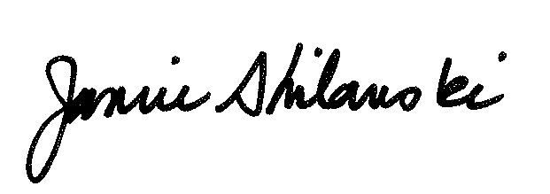

I. General Description

This position is required to fill in for/assist the landfill technician with all essential duties associated with the landfill.

II. Reasonable Accommodations

To perform this job successfully, an individual must be able to perform each essential job duty and physical demands satisfactorily. Reasonable accommodations may be made to enable individuals with disabilities to perform the essential duties.

III. Essential Job Duties

- Operate heavy equipment required in the daily operations of the landfill, which includes dozers, loaders, front-end loaders and backhoes.
- Assist with the discharge of solid waste by the public and contractors.
- Enforce the ordinances and resolutions as they pertain to the landfill.
- Collection of landfill fees.
- Securing the landfill during closed periods.

IV. Knowledge, Skill, and Abilities

Knowledge:
This position requires proficiency in the following areas:
- Operation and maintenance of heavy equipment required in the operation of the landfill.
- Ordinances and resolutions associated with the landfill and the transportation of solid waste.
- State and federal regulations as they relate to landfill operations.

Skills & Abilities:
This position must demonstrate the following skills and abilities:
- Interact with the public in a courteous, helpful and professional manner.
- Work with co-workers, outside agencies, and vendors in a professional manner.

V. Work Environment and Physical Effort

The Landfill Operator can be a physically strenuous and demanding job. He/she will be lifting, pulling and managing heavy equipment and objects. The Landfill Operator will have to work in all weather, and must be prepared for both extreme heat and cold. The Landfill Operator occasionally works

near moving mechanical parts; in high, precarious places; and is occasionally exposed to fumes or airborne particles, toxic or caustic chemicals, risk of electrical shock, and vibration.
While performing the duties of this job, the employee is regularly required to walk; use hands to finger, handle, or feel objects, tools, or controls; reach with hands and arms; and talk or hear. The employee frequently is required to sit.
The Landfill Operator must occasionally lift and/or move up to 50 pounds. Specific vision abilities required by this job include close vision, distance vision, color vision, peripheral vision, depth perception, and the ability to adjust focus.

VI. Education and/or Experience

Education:
- High school or General Equivalency Degree (GED).

Experience:
- Must be at least 19 years of age.
- Must have a valid Alaska Driver’s License

VII. Certification and Training

- National Incident Management System (NIMS) compliance training and certification.
- Must get a Commercial Driver’s License (CDL) within 6 months of hire.
- Must acquire Rural Alaska Landfill Operators (RALO) certification or ability to obtain within six months of date of hire.
- Certified in proper handling and disposal of refrigerants.

VIII. Supervisory Responsibility

None

IX. Scope of Employment

Regular, full time employment. non-exempt position. Rotating shifts.

X. Acknowledgment

I understand the duties of this position as detailed in this job description.

Employee: Date:___________________________

This job description is accurate and has been reviewed with the above employee:

Supervisor: Date:___________________________

