Example of using a map and graphics to show your solid waste situation

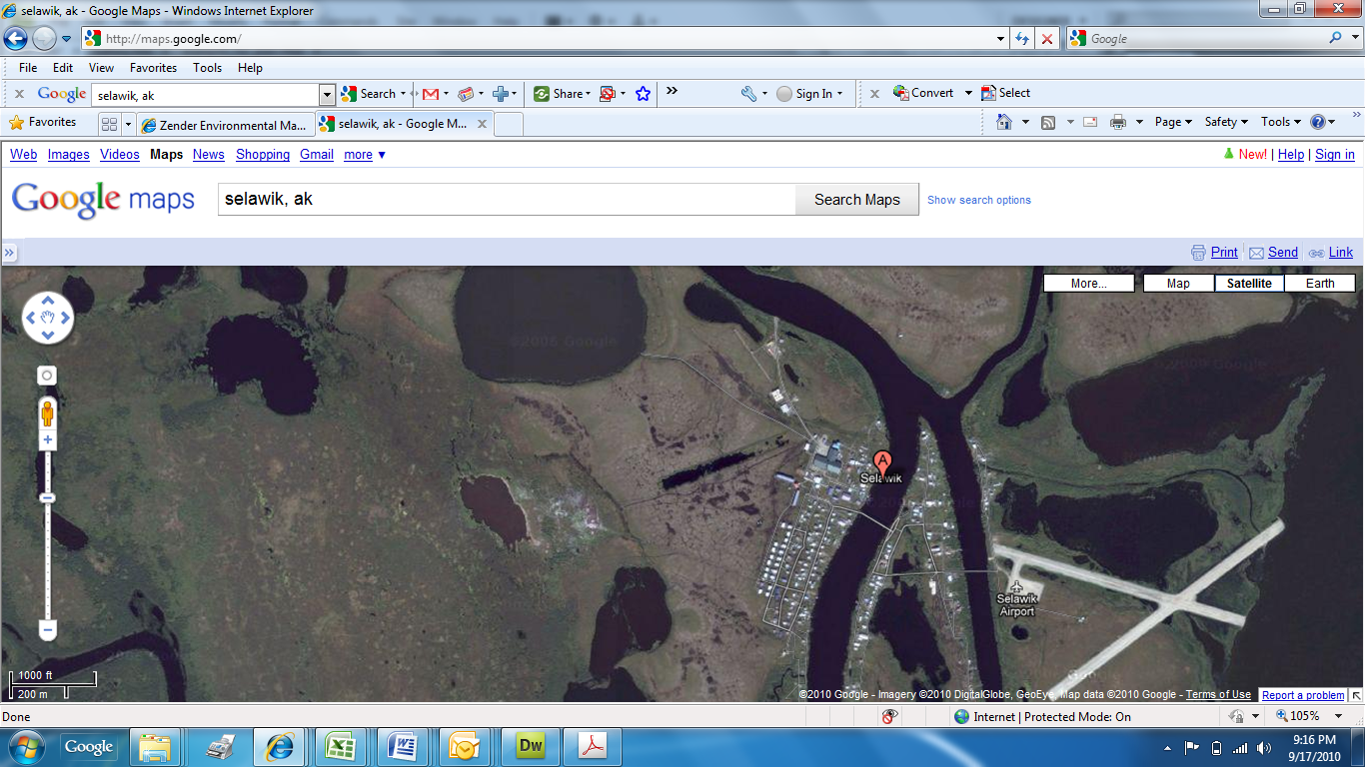

Drainage from waste site

Solid Waste Site

Drainage from waste site (overland flow)

Predominant Wind Direction

School

1500 feet