WATER QUALITY MONITORING

QUALITY ASSURANCE PROJECT PLAN

For
Chickaloon Native Village
Baseline Water Quality Monitoring Project

Prepared by
Chickaloon Native Village
Environmental Stewardship Department

Prepared for
US Environmental Protection Agency
IGAP Grant Program
Table of Contents
Acknowledgements 4
1. Project Management and Organization 5
1.1. Approval Page 5
1.2. Distribution List 6
1.3 Project Organization 7
1.4 Roles and Responsibilities 7
1.5 Background/ Problem Identification 8
1.6 Project Description 9
1.6.1 Table: Annual Schedule of Tasks 10
1.7 Project History 10
1.8 Data Quality Objectives 10
1.8.1 Precision and Accuracy 10
1.8.2 Data Representativeness 11
1.8.3 Data Comparability 11
1.8.4 Data Completeness 12
1.9 Training Requirements 12
1.9.1 Training Topics 12
1.10 Documentation and Records 12
2. Measurement and Data Acquisition 13
2.1 Sampling Process Design 13
2.1.1 Sample Site Selection 13
2.1.2 Sampling Parameters 14
2.1.3 Sampling Frequency 14
2.1.4 Site Safety Plans 14
2.2 Sampling Methods Requirements 14
2.3 Analytical Methods Requirements 15
2.4 Instrument/Equipment Testing, Inspection and Maintenance Requirements 15
2.5 Instrument Calibration and Frequency 16
2.6 Inspection and Acceptance Requirements for Supplies 16
2.7 Data Management 16
3. Assessment and Oversight 17
3.1 Assessment and Response Actions 17
3.1.1 Project Level Assessments (Internal Project Assessments) 17
3.1.2 Program Level Assessments (External Project Assessments) 17
3.2 Response and Corrective Actions 17
3.3 Reports 18
4. Data Validation and Usability 18
4.1 Data Review, Validation and Verification Requirements 18
4.2 Validation and Verification Methods 18
4.2.1 Data Verification 18
4.2.2 Data Validation 18
4.3 Reconciliation with Data Quality Objectives 19
Appendix A: Technical Advisory Committee (TAC) List 20
Appendix B: Personnel Training Records 21
Appendix C: Standard Operating Procedures (SOPs) 22
C.1 Field Sampling 22
C.2 Calibration 26
C.2.1 Hanna HI98703 Portable Turbidimeter 26
C.2.2 YSI Multi Probe System 29
Appendix D: Forms 35
D.1 Inspection Datasheet 35
D.2 Sample Collection Datasheet 36
D.3 Equipment Calibration Sheets 38
D.3.1 Hanna HI98703 Portable Turbidimeter 38
D.3.2 YSI Multi Probe System 39
D.4 Corrective Action Form 40
D.5 Sample Alteration Form 41
Appendix E: Sampling Stations 42
E.1 Sampling Stations List 42
E.2 Map of Sampling Stations Locations 43
Appendix F: Data Quality Objectives Summary Table 44
Appendix G: Sampling Frequency Table 45

Acknowledgements
This Quality Assurance Project Plan (QAPP) for baseline water quality is written under an Indian Environmental General Assistance Program (IGAP) grant from the U.S. Environmental Protection Agency (EPA) for building Tribal environmental program management capacity. We thank them for their generous support of our vision to create a healthy community for the people of Chickaloon Native Village.
Additional thanks goes to those who graciously volunteered to be part of the Technical Advisory Committee (TAC) that is listed in Appendix A.

1. Project Management and Organization

1.1. Approval Page
Name | Chief Gary Harrison
Title | Traditional Council Member
Organization | Chickaloon Native Village
Signature | _____________________________________________ | Date | _____________

Name | Gene Agnew
Title | Project Manager
Organization | Chickaloon Native Village
Signature | _____________________________________________ | Date | _____________

Name | Jessica Winnestaffer
Title | Quality Assurance Officer
Organization | Chickaloon Native Village
Signature | _____________________________________________ | Date | _____________

Name | Katherine Brown
Title | Tribal Specialist
Organization | Office of Ecosystems, Tribal and Public Affairs  US EPA Region 10
Signature | _____________________________________________ | Date | _____________

Name
Title | Regional Quality Assurance Manager
Organization | Office of Environmental Assessment  US EPA Region 10
Signature | _____________________________________________ | Date | _____________

1.2. Distribution List
Official copies of this QAPP, accompanying documents and any subsequent revisions will be provided to:
Tribal Community
Name | Chickaloon Village Traditional Council
Title | Traditional Council Members
Organization | Chickaloon Native Village  cvadmin@chickaloon.org; 907-745-0749
Name | Gary Hay
Title | Executive Director
Organization | Chickaloon Native Village  ghay@chickaloon.org; 907-745-0749
Name | Brian Winnestaffer
Title | Transportation Director
Organization | Chickaloon Native Village  brianw@chickaloon.org; 907-745-0854
Name | Jessica Winnestaffer
Title | Environmental Stewardship Director
Organization | Chickaloon Native Village  jessica@chickaloon.org; 907-745-0737
Name | Gene Agnew
Title | Environmental Stewardship Assistant Director
Organization | Chickaloon Native Village  genea@chickaloon.org; 907-745-0737

U.S. Environmental Protection Agency
Name | Katherine Brown
Title | Tribal Specialist
Organization | Office of Ecosystems, Tribal and Public Affairs, US EPA Region 10  brown.katherine@epa.gov; 206-553-7263
Name
Title | Regional Quality Assurance Manager
Organization | Office of Environmental Assessment, US EPA Region 10
Name | Matthew LaCroix
Title | Biologist
Organization | EPA Alaska Office of Ecosystems, Tribal and Public Affairs Aquatic Resources Unit  lacroix.matthew@epa.gov; 907-271-1480

University of Alaska Anchorage
Name | Daniel Bogan
Title | Aquatic Ecologist, Technical Advisor
Organization | Aquatic Ecology Program of the Alaska Natural Heritage Program  dlbogan@uaa.alaska.edu; 907-786-4964

Water Scientist
Name | Kendra Zamzow
Title | Staff Scientist
Organization | Center for Science in Public Participation  kzamzow@csp2.org; 907-354-3886

1.3 Project Organization
Name | Project Title
Chief Gary Harrison | Chickaloon Village Traditional Council Member
Rick Harrison | Chickaloon Village Traditional Council Member
Penny Westing | Chickaloon Village Traditional Council Member
Albert Harrison | Chickaloon Village Traditional Council Member
Doug Wade | Chickaloon Village Traditional Council Member
Shawna Larson | Chickaloon Village Traditional Council Member
Kari Shaginoff | Chickaloon Village Traditional Council Member
Lisa Wade | Chickaloon Village Traditional Council Member
Kendra Zamzow | Technical Advisory Committee
Daniel Bogan | Technical Advisory Committee
Matthew LaCroix | Technical Advisory Committee
Brian Winnestaffer | Technical Advisory Committee
Gene Agnew | Project Manager
Jessica Winnestaffer | Project Quality Assurance Officer

1.4 Roles and Responsibilities
Chickaloon Village Traditional Council (CVTC) Responsibilities
The current CVTC Council members include Chief Gary Harrison (Traditional Chief and Chairman), Rick Harrison (Vice-Chairman), Penny Westing (Secretary/Elder), Albert Harrison (Treasurer/ Elder), Doug Wade (Elder), Shawna Larson, Kari Shaginoff, and Lisa Wade. The main responsibility of CVTC includes providing historical and cultural information about the water resources that are being monitored based on observations and experiences with the water resources and surrounding natural environment. Tribal Elders will be consulted to assist CVTC in understanding and documenting Traditional Knowledge and making decisions that could affect the Tribe's present day cultural.

Technical Advisory Committee (TAC) Responsibilities
The current TAC includes Kendra Zamzow, Daniel Bogan, Matthew LaCroix, Brian Winnestaffer, and a Chickaloon Village Traditional Council Member. The TAC's main responsibilities include reviewing the monitoring plan and associated standard operating procedures as well as reviewing results and reports of annual monitoring efforts. The TAC members may, at any time, ask for additional information on any aspect of the project. If monitoring data raises a particular question or concern, the TAC will be consulted and asked to suggest and review any changes to the monitoring plan.

Project Manager (PM) Responsibilities
Gene Agnew is the PM and is the primary contact point for technical objectives, sampling, analytical procedures, quality assurance (QA) requirements, problem resolution, and general implementation of the QAPP. The Project Manager oversees the water quality monitoring efforts and other project activities, provides and ensures that project team members conducting water quality monitoring have completed all of the required water quality monitoring training elements and refresher courses. The Project Manager prepares the project QAPP and its subsequent revisions as well as the annual project report.

Project Quality Assurance Officer (QAO) Responsibilities
Jessica Winnestaffer is the QA Officer and ensures that the QAPP incorporates adequate QA/QC measures to meet the data quality objectives set forth by the project and that the QAPP is reviewed and approved by appropriate approving personnel. The QA Officer also ensures the QA/QC measures specified in the QAPP are effectively implemented throughout the duration of the project. The QA Officer coordinates and facilitates technical, performance and quality system audits conducted by appropriate authorities at the project specified frequency.

Field Sampling Leader (FSL) Responsibilities
The Field Sampling Leader is responsible for overseeing the timely completion of assigned fieldwork with the strict adherence to the QAPP's activity and task schedules and Standard Operating Procedures (SOPs). Specific training is required as outlined in the Training Requirements section.

1.5 Background/ Problem Identification
Chickaloon Native Village (Chickaloon Tribe, Chickaloon Village, Tribe) considers care of the land and all creatures that live upon it to be a primary responsibility. Traditionally, Chickaloon Village Tribal citizens stewarded and cared for the land in all of the Tribe’s traditional territory including the Matanuska River watershed. Rough boundaries of this territory include the Talkeetna Mountains to the north, the Copper River Watershed to the east, the Chugach Mountains to the south, and Cook Inlet to the west. Today most of these lands are no longer under direct Tribal control, however the Tribe chooses to use the public opportunity to steward public lands and waters following landowner rules and guidelines.
Chickaloon Native Village is one of few Alaska Native Tribal villages located on Alaska’s road system, and Chickaloon Village is unique. Chickaloon Native Village does not currently have a central village site; instead many Chickaloon Village Tribal citizens live along the edges of the Matanuska River from the Matanuska Glacier to Cook Inlet. Being located on the road system subjects the community to unusually high development pressure. In fact, the Matanuska-Susitna Borough (MSB), in which the Matanuska River is located, is the fastest growing area in the State of Alaska. Between 1980 and 1990, the population increased 123 percent, growing an additional 49 percent between 1990 and 2000. Between 2000 and 2012, the MSB’s population grew by 58 percent, while Anchorage grew by 15 percent and the state a whole grew by 17 percent. Current and potential changes in land use and management resulting from this growth are having an unknown impact on water quality. Some impacts of past developments are better understood.
Non-traditional, non-Tribal development of Chickaloon Native Village’s traditional lands began in earnest in the early 1900’s following the mapping of large deposits of high quality coal in the Matanuska River watershed, specifically along the Chickaloon River, Eska Creek and Moose Creek. Chickaloon Native Village’s oral history states that mining activity by the U.S. Navy decimated Chickaloon River salmon runs. The Chickaloon River is a major tributary of the Matanuska River and a traditional source of salmon upon which the Chickaloon Tribe depended for food. In 1917 the U.S. Navy constructed and peopled a town on the banks of the Chickaloon River at the site of the Chickaloon Mine. Mine tailings and town wastes were carelessly dumped directly into the Chickaloon River leading to the noted salmon disappearance.
Moose Creek, another traditional source of salmon for Chickaloon Native Village, was also negatively impacted by coal mining operations. In the 1920’s construction of a rail spur to the coal mines on the banks of Moose Creek straightened and diked the creek for more railroad operation space. The straightened sections caused the creek to flow faster and the water to be more turbulent, triggering erosion of the creek bed and over time resulting in several bedrock waterfalls, including one 10-foot high waterfall that prevented the upstream passage of anadromous fish. In 2005 and 2006 Chickaloon Native Village completed the award-winning Moose Creek Fish Passage Restoration Project that restored Moose Creek to its original, sinuous channels at two sites of fish passage barriers, to allow fish (including salmon) access to the upper Moose Creek watershed.
Since the 1990’s coal mining has again been permitted in the Moose Creek watershed and Chickaloon Native Village is very concerned about possible water quality impacts to Moose Creek, surrounding streams and surface waters as well as ground water systems.
While past development projects have negatively impacted the natural resources of the Matanuska River watershed and its sub-watersheds at certain times, it is unknown whether pollution and human impacts are harming these watersheds today. Little to no baseline water quality data is available to determine the effects of point and non-point source pollution on the water quality of the streams and rivers of the Matanuska River basin.

1.6 Project Description
The focus of this study is to develop a baseline data set of surface water quality in the Matnuska Watershed of southcentral Alaska. This study includes sampling tributaries and/or water bodies of the Matanuska River as listed in Appendix E: Sampling Station List. CVTC will conduct physical and chemical monitoring including the analytes listed in Appendix F: Data Quality Objectives Summary Table.

The objectives of Chickaloon Native Village's baseline water quality assessment are to:

- Use traditional knowledge to identify potential surface water quality sampling sites and areas of concern;
- To assess impacts from present activities including residential developments and highway;
- To develop baseline information to protect water from future impacts using Tribal, federal and state laws. This may involve many years of data gathering;
- To develop a baseline screening for water quality and identify potential impacts to water quality which involves screening for problems and is intended to guide more refined efforts in the future;
- To file for listing as “at risk” or “impaired” water body under Clean Water Act;
- To file for in-stream flow for fish and wildlife, water quality, or aesthetic value;
- To collect consistent, continuous temperature data for local streams;
- Raise awareness of tribal citizens and other community members through information dissemination;
- Develop baseline data for potential use in formulating Tribal water quality standards to ensure the protection of water quality for future generations.

1.6.1 Table: Annual Schedule of Tasks
TASK CATEGORIES | Personnel Responsible | Oct | Nov | Dec | Jan | Feb | Mar | Apr | May | Jun | Jul | Aug | Sep
Training | PM |  |  |  |  |  | X | X | X
Performance Evaluations & Recertification (Appendix B) |  |  |  |  |  |  | X | X | X
Testing for general physical and chemical parameters (water chemistry monitoring) | CVTC ESD | X | X | X | X | X | X | X | X | X | X | X | X
Installing/removing water temperature loggers | CVTC ESD |  |  |  |  |  |  |  | X | X
Data Entry | PM/ CVTC ESD |  |  | X |  |  | X |  |  | X |  |  | X
Quarterly Data Verification and Validation | CVTC QAO | X |  |  | X |  |  | X |  |  | X
Internal Technical System Review (annually) | PM/QAO | X
Annual External Technical System Review | TAC |  |  |  | X | X
Annual QAPP review/revision | PM/CVTC QAO | X | X
Review and Approval of QAPP Revision | CVTC/EPA Grant Coordinator/EPA QA Manager |  | X | X
Annual Project Report | PM/QAOs to EPA | X | X

1.7 Project History
Chickaloon Native Village has previously completed two years of baseline chemical and biological water quality sampling in approximately ten Matanuska River watershed streams. Staff from the CVTC Environmental Stewardship Department (ESD) were funded by a grant from the U.S. Department of Health and Human Services Administration for Native Americans (ANA). New equipment, refinements in methods and additional testing parameters have been incorporated in this revision of the QAPP. As future funding allows, this baseline water quality sampling project will be expanded using local citizen volunteers. This QAPP will be updated and submitted for re-approval when the citizen sampling element is added to the project.

1.8 Data Quality Objectives
Data Quality Objectives (DQOs) are the quantitative and qualitative terms used by EPA to describe the level of quality the data need to be in order to meet the project's objectives. DQOs for measurement data, also commonly referred to as data quality indicators, are precision, accuracy, representativeness, completeness, comparability, and measurement range sensitivity. The overall QA objective for analytical data is to ensure that data of known, acceptable and legally defensible quality are generated. To achieve this goal, data must be reviewed for 1) precision, 2) accuracy or bias, 3) representativeness, 4) comparability, and 5) completeness.
The summary of DQO requirements for this project listing the suite of parameters for analysis, analytical methods, frequency of collection and analysis of QA/QC samples, precision, accuracy, and completeness requirements are outlined in Appendix F – Data Quality Objectives Summary Table.

1.8.1 Precision and Accuracy
Precision is the degree of agreement among repeated measurements of the same characteristic, or parameter, and gives information about the consistency of methods. Accuracy is a measure of confidence that describes how close a measurement is to its “true” value. Replicate measurements are taking two samples from the same location from the same field event, and duplicate measurements are taking one sample in one location and having it analyzed as two samples in a laboratory. Replicate measurements will be performed during each testing event, monitoring and training sessions and during annual performance evaluation and re-certification. Replicate measurement acceptability criteria each sampling parameter are described in Appendix F - Data Quality Objectives Summary Table.

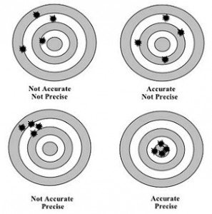

Field analytical precision will be evaluated by the relative percent differences (RPD) between field replicate samples during one sampling. The target RPD goals for this project are outlined in Appendix F – Data Quality Objectives Summary Table.

RPD is calculated using the following formula:

(R1 - R2)
RPD = x 100
((R1 + R2)/2)

Where: R1 = the larger of the two replicate values
R2 = the smaller of the two replicate values

Field accuracy will be routinely checked according to the instrument and analytical method accuracy requirements of each parameter as outlined in Appendix F - Data Quality Objectives Summary Table.

1.8.2 Data Representativeness
Representativeness is the extent to which measurements actually represent the true environmental condition. It is the degree to which data from the project accurately represent a particular characteristic of the watershed that is being tested. Representativeness of samples is ensured by adherence to standard protocols for equipment calibration, field sampling, and measurements. The design of the sampling scheme and number of samples for this project provide representativeness of the part of the watershed being sampled. As a whole, representativeness of the samples collected for this project will be determined during data assessment and data interpretation phase.

1.8.3 Data Comparability
Comparability is the degree to which data can be compared directly to similar studies. Using standardized calibration and sampling protocols, the same or comparable analytical methods and units of reporting with comparable sensitivity helps ensure comparability. This Baseline Water Monitoring project has selected testing methods that are EPA approved and/or currently being employed by other water quality monitoring programs throughout the country. As this project expands, additional site selections will favor locations where previous water quality monitoring has taken place. Efforts will be made to duplicate the efforts of past studies where possible.

1.8.4 Data Completeness
Completeness is the comparison between the quantity of usable data collected versus the total data collected. Completeness is the percentage of valid results obtained compared to the total number of samples taken for a parameter. The target completeness goal for this project shall be 90% or better.

% Completeness is calculated using the following formula:

% Completeness (per parameter) = # of valid results x 100
Total # of samples taken

The sampling parameters measured and analytical methods are listed in Appendix F – Data Quality Objectives Summary Table. This table will be used for evaluating and determining the quality, bias and usability of the data generated for this project. Completeness will be calculated during the data validation process.

1.9 Training Requirements
To be able to participate as a Field Sampling Leader (FSL), participants are required to complete a water quality training program that meets or exceed CVTC standards outlined below and maintain proficiency through annual performance evaluations and recertification. The CVTC approved water quality training and certification program consists of at least 3-days of training to include all of the items listed under 1.9.1 Training Topics.
Annual 1-2 day performance evaluations, workshops and re-certifications are conducted and logged. Personnel performance is evaluated during training and annual performance evaluation and re-certification sessions. Trainers make note of each participant’s precision and accuracy for all testing methods and comment on overall understanding of monitoring procedures.

1.9.1 Training Topics
- Water chemistry and effects on water quality
- Maintaining equipment and supplies
- Managing data
- Assuring data quality
- Practice evaluation of sampling site
- Practice testing methods
- Practice documentation
Personnel training and recertification completions will be logged in Appendix B – Personnel Training Records and all training certificates will be located with CVTC Human Resources.

1.10 Documentation and Records
All data gathered during this project are recorded on site at the time sampling occurs. The data to be recorded for each sampling site are identified on the Sample Collection Datasheet in Appendix D - Forms. Personnel are instructed to fill out the datasheet legibly and completely and to the decimal point identified for each parameter on the Sample Collection Datasheet. Data is entered using an indelible marker. If a mistake is made, one line is drawn through the characters in question and the new characters are entered adjacent to the lined-out entries. The date and FSL’s initials are entered immediately after the new characters.
Personnel are also instructed to use the comment section of the datasheet to report any problems or abnormalities with sampling procedures, data, or equipment. All records and documents are kept at the CVTC ESD office and are available for inspection at any time.
Monitoring equipment and supplies are inspected by the Project Manager upon receipt and again by the Project Quality Assurance Officer (QAO) during QC sessions. Equipment inspection forms are kept up to date for each piece of equipment and are kept at the CVTC ESD office and are available for inspection at any time.

2. Measurement and Data Acquisition

2.1 Sampling Process Design

2.1.1 Sample Site Selection
In order to meet the project objectives (described in Project Description), the project's design calls for selecting multiple sample sites within the Matanuska River watershed. Each sample site will be given a project name and identified by a sample site number and a location description, as well as by its latitude, longitude, and elevation as determined by using either a GIS mapping program, a USGS topographical map, or a GPS unit. The following criteria were considered in selecting sample site locations:
- Traditional Ecological and Local Knowledge – Information will be collected from Elders and local community members. This will include observations and experiences with the proposed water body. Special consideration will be given to water bodies where Tribal ceremonies have taken place or currently take place.
- Private Property Access – If a site requires entering or crossing private property, the landowner(s) should be consulted during the site selection process. The CVTC ESD will be responsible for obtaining landowner permission, in writing, prior to using any sample site that enters or crosses private property.
- Historical Data – The Matanuska River watershed is known for the annual migration of five species of salmon and presence of fresh water fish species. Also water quality data has been previously collected on some tributaries. Special consideration is given to water bodies and sample sites where water quality or ecological data have previously been collected.
- Parameters Previously Measured – Consideration is given to which of the parameters previously measured at each site coincide with the parameters measured in this project.
- Representativeness – Sample sites should be located to be representative of a particular reach and not targeted to one specific point source or outfall.
- Logistical Access and Safety – Consideration will be given to select sample sites that are safe and reasonably accessible, such as avoiding high flow water, avoiding thin ice, avoiding steep/eroding/undercut banks, avoiding sites with obvious bear activity, minimizing highway/ bridge hazards, and reducing distance required to walk in with equipment.
Expansion of the project to include additional sample sites will be based on the same criteria.

2.1.2 Sampling Parameters
As described in Project Description section, testing parameters were selected based on their usefulness in inventorying water quality and projecting the general “health” of the water bodies in question. Consideration was also given to data collected by previous studies on these streams and to the costs related to testing each parameter as related to available funding. The sampling parameters for this project are: pH, dissolved oxygen, water temperature, specific conductance, ORP, turbidity, barometric pressure, and air temperature.

2.1.3 Sampling Frequency
Sampling will take place as outlined in Appendix G - Sampling Frequency Table. All efforts will be made to perform water quality sampling at the frequency of at least once a month from November to March for each sampling site, and at least twice a month from April to October for each sampling site, to get a good representation of each site throughout the ice-free season.
The impact of rain events on water quality is also a factor in this project. It is important to do sampling before, during and directly after high water events. Additionally it is important to sample during the winter low-flow period, if possible, or at the earliest opportunity in the spring with open water at the sampling sites. Personnel will strive to maintain a regular monitoring schedule regardless of precipitation and will always document weather conditions at the time of sampling. Sampling frequency for all parameters measured in this project and the minimum sampling frequency are shown in Appendix G - Sampling Frequency Table.

2.1.4 Site Safety Plans
The following safety precautions discussed below do not constitute a safety plan, and approval of this QAPP does not constitute a safety plan approval.
Sampling sites are selected, in part, because they are in general safely accessible. Personnel are instructed to always use their best judgment when in the field, choose safety of personnel above all other goals, and to use great caution when sampling water quality during extreme weather or stream conditions. Personnel are instructed to use safe access routes and will be warned of any known site-specific hazards. Whenever possible, samples are collected by a field sampling team. In winter months, personnel are advised to exercise extreme caution at sampling sites with no direct road or winter trail access.
Personnel may, at times, chop and maintain holes in ice-covered sites, but they are strongly discouraged from sampling if there is any question about the strength of the ice and whether it can support them safely.
Personnel will use appropriate safety equipment during sampling and analysis. This can include: protective eye wear, rubber gloves, personal flotation devices, and dusk masks. Personnel who must sample their sites by wading in from shore will wear rubber boots or waders, dress appropriately and be prepared for variable weather conditions.

2.2 Sampling Methods Requirements
Sampling methods for the project’s sampling parameters are outlined in Appendix C - Standard Operating Procedures (SOPs), which identifies the instruments used and the parameter(s) each instrument measures, as well as any additional sampling equipment or container(s). In situ measurements of all parameters will be collected from streams and rivers at mid-depth and at mid-stream when safety allows otherwise next to the shore.

2.3 Analytical Methods Requirements
The parameters and sampling analytical methods for this project are listed in Appendix F – Data Quality Objectives Summary Table.
2.4 Quality Control Requirements
The following QA and QC measures are taken to assure the quality of the data collected:
- All of the personnel directly involved with this water quality monitoring project are required to complete water quality training as outlined in the Training Requirements section.
- All of the personnel directly involved with this project are required to attend annual re-certification training to review sampling procedures and maintain proficiency skills in sample collection and data generation. Re-certification training shall include the analysis of blind performance evaluation (PE) samples per water quality parameter. The re-certification will serve as an overall check of personnel performance and proficiency.
- Replicate measurements shall be performed in the field for every measurement. Precision of the replicate analyses shall be within the acceptable criteria set forth by the instrument and listed in Appendix F – Data Quality Objectives Summary Table. Replicate measurements that do not meet the precision criteria will be flagged in the project database. Should there be unacceptable precision results, no other measurements for the parameter in question shall be conducted until the issue is identified and resolved. Problems encountered will be documented in Corrective Action Form and deviations from the QAPP shall be documented in the Sample Alteration Form, which are both located within Appendix D – Forms.
- Three levels of data verification will be employed: sample collection datasheet review by the Field Sampling Leader, data review by the Project Manager, and final evaluation and approval by the Project QA Officer. Data that do not meet the DQO of the project are appropriately flagged or qualified in the database during the data verification and validation process.
- When applicable, calculations are performed automatically by a computer program after entering the data into the database, thus, removing or minimizing the occurrence of errors.
- In consultation with the TAC, EPA and other technical specialists, data are evaluated for consistency and reliability.
- Internal data validation shall be performed to assess the progress and effectiveness of the project annually.
- This project receives comments and technical advice from the TAC. A list of the TAC members is shown in Appendix A – Technical Advisory Committee List.

2.4 Instrument/Equipment Testing, Inspection and Maintenance Requirements
Appendix C - Standard Operating Procedures (SOPs) documents the proper handling, use, and maintenance of each field instrument (also known as field equipment). The following are the responsibilities of the project personnel with regards to instrument maintenance and reagent use:
- Upon receiving any instrument or chemical reagent, the project personnel shall inspect and/or test to insure it is in good working condition and log the inspection into the Inspection Form in Appendix D - Forms.
- Before each sampling event, the project personnel shall inspect and calibrate or test all instruments and reagents and ensure that they are clean and in good working condition.
- If any instrument or chemical reagent is found to be defective in any way, the project personnel shall contact the manufacturer and arrange for immediate replacement or repair.
- Whenever a faulty instrument or reagent is replaced, it is documented on the Equipment and Reagent Inspection Data Sheet, found in Appendix D – Forms, and located in the office project file.
- The project personnel shall maintain an adequate supply of expendable needs of the project (e.g. reagents, parts, tools, etc.) located at the CVTC ESD office. The quantity of reagent maintained in the office shall be carefully estimated to assure that replenishments are received before exhaustion of the supply and that stored supplies do not exceed expiration dates.
- Reagent stocks are to be rotated out upon expiration.

2.5 Instrument Calibration and Frequency
All of the field instruments and equipment shall be calibrated for each sampling parameter prior to each day’s field collection except for dissolved oxygen (DO). DO will be calibrated in the field at each site before sample measurement. All calibration procedures will be done following the described methods in Appendix C- Standard Operating Procedures (SOPs). Calibration log forms are provided in Appendix D – Forms.
Any and all commercial laboratory instrumentation and equipment used in the analysis for this project shall be calibrated prior to sample analysis in accordance with the technical specifications and procedures specified in the analytical method used.

2.6 Inspection and Acceptance Requirements for Supplies
Monitoring instruments and supplies are ordered from various manufactures and are inspected upon arrival by project personnel. An Inspection Form is provided in Appendix D - Forms, which should be completed, including reagent expiration dates, and kept on file at the CVTC ESD office. Broken bottles, incomplete kits, reagents, or instruments that do not meet standards are shipped back to the manufacturer for replacement.

2.7 Data Management
Project personnel shall collect and report data on the datasheet(s) provided in Appendix D - Forms for this project. All observational data, water quality data and field measurements are recorded at the time of sampling and analysis. All personnel sign the datasheets. The datasheets are kept and maintained in an organized file in the CVTC ESD office.
Field datasheets and other sample documentation shall be initially reviewed by the Project Manager prior to data entry to the project database for precision, completeness, and other general problems.
The project personnel shall ensure that data generated are accurately entered into the Chickaloon Village Water Quality (CVWQ) database. The CVWQ database is still under development and testing stages and when completed shall be compatible with the EPA STORET/WQX database. Data will be exported through the Internet to the EPA STORET/WQX database to the extent allowed by the governing body. Once in the STORET/WQX database the data will be available to the extent allowed by the governing body spatially through the Internet at the Alaska's Cooperatively Implemented Information Management System (CIIMMS) website.
Data are reviewed regularly by the project personnel, and will be presented in an annual report as outlined in the Reports section.

3. Assessment and Oversight

3.1 Assessment and Response Actions

3.1.1 Project Level Assessments (Internal Project Assessments)
- All project personnel shall undergo a re-certification process which includes the analysis of blind performance evaluation (PE) samples for the water quality parameters that have PE samples, as an overall check of personnel performance and proficiency.
- Three levels of data verification shall be employed: sample collection datasheet review by the Field Sampling Leader, data review by the Project Manager, and final evaluation and approval by the Project QA Officer. Data that do not meet the DQO of the project are appropriately flagged or qualified in the database during the data validation process.
- The Technical Advisory Committee will review this QAPP and the overall project design annually and may suggest procedural refinements or additional testing procedures. This may include new parameters to be measured or changes to procedures currently in use. Any such changes will be subject to EPA approval. The project is open to EPA system audits at their discretion. An internal QA assessment and technical system review (TSR) shall be conducted by the TAC for the project to assess the progress and effectiveness of the project annually.

3.1.2 Program Level Assessments (External Project Assessments)
A TSR of the project shall be conducted by EPA or contractor to assess the progress and effectiveness of the project annually, or as requested by the program.
In addition to the PE samples analyzed during re-certification, depending on funding and availability, additional performance evaluation samples may be submitted blind to the project personnel for field measurement analysis at least once per year. A PE sample may be submitted blind to any contract laboratory to test proficiency.

3.2 Response and Corrective Actions
Problems encountered during sample collection and data generation shall be handled as soon as possible. No measurements will be generated by an instrument or piece of equipment that did not meet the technical specifications of the manufacturer or the method SOP. Problems that may have a big impact on data quality shall be properly documented and resulting data will be flagged accordingly.
Any failure to meet data quality objectives will be evaluated. If the cause is found to be equipment failure, calibration and maintenance procedures will be reassessed and improved. If the problem is found to be personnel error, personnel will work with the Project QA Officer to resolve the problem. If accuracy and precision goals are frequently not being met, QC sessions will be scheduled more often.
If failure to meet program specifications is found to be unrelated to equipment, methods, or personnel error, the QAPP may be revised. Revisions and subsequent modifications and amendments to this QAPP shall be submitted to the approval list for review and approval.

3.3 Reports
Annual reports will be provided and will describe activities during the previous year. These reports will consist of data results, interpretation of data, information of project status, highlights, results of QC audits and internal assessments.
The PM is responsible for the preparation of the Annual Report. The project personnel are responsible for report production and distribution. Annual reports will be submitted to CVTC and the regional office of EPA and all other parties listed in the Distribution List of this document as well as the TAC. Summaries of all reports highlighting the assessment results, project status and achievements will be distributed to CVTC.

4. Data Validation and Usability

4.1 Data Review, Validation and Verification Requirements
All data collected by project personnel is subject to review by Project Manager to determine if the data meet QAPP objectives. Decisions to flag or qualify data are made by the Project QA Officer.

4.2 Validation and Verification Methods

4.2.1 Data Verification
Datasheets must be filled out completely and signed by all monitors present at the time of sampling and analysis. There will be at least three levels of data verification for this project:
- Field datasheet review by the Field Sampling Leader
- Data review by Project Manager.
- Final evaluation and approval by the Project QA Officer.
During this data verification process, datasheets for calibration and measurements and chain-of-custody records shall be checked and evaluated for precision, missing or illegible information, errors in transcription and calculation and values outside of the expected range.
When field datasheet review is completed and any concerns addressed, each datasheet is signed and dated by the Project Manager. If data quality questions cannot be adequately resolved, data will not be entered into the data system and the Project QA Officer will arrange for corrective measures (i.e. re-training, equipment re-calibration, etc.). Any changes made to the data are initialed and dated, and any action taken as a result of the data review is specifically recorded on the datasheet with the Project QA Officer signature and date.

4.2.2 Data Validation
Data validation shall be conducted on all data generated for this project by the Project Manager. Data that do not meet the DQO of the project will be appropriately flagged or qualified in the database during the data validation process.
On a quarterly basis, the Project QA Officer proofreads all previously flagged data in the database and compares them to their corresponding datasheets. Also, the Project QA Officer proofreads and compares all datasheets with the database. Errors in data entry are corrected. RPDs are reviewed and high RPDs are flagged for further review. All anomalies or inconsistencies are noted in the database. Data are presented annually using a narrative report format. The annual report includes baseline water quality data; identifiable trends; successes and deficiencies in data collection, program design and data quality; resolutions used to address any issues; and graphs, tables and photographs. Annual reports are prepared and distributed to the list provided in this QAPP.
Members of the TAC are asked to review these reports and offer suggestions for improving this project.

4.3 Reconciliation with Data Quality Objectives
Data generated by this project are evaluated and assessed in accordance with the DQOs listed in Appendix F – Data Quality Objectives Summary Table. All of the data generated are reported in the database. Data that are outside the DQO goals of the project are appropriately flagged or qualified in the database with a short narrative defining the qualifier and its effect to the quality of the data.

Appendix A: Technical Advisory Committee (TAC) List

Name | Brian Winnestaffer
Title | Chickaloon Native Village Transportation Director
Contact | brianw@chickaloon.org; 907-745-0854

Name | Chickaloon Village Traditional Council Member
Title | Council Member
Contact | cvadmin@chickaloon.org; 907-745-0749

Name | Kendra Zamzow, Ph.D.
Title | Staff Scientist at the Center for Science in Public Participation
Contact | kzamzow@csp2.org; 907-354-3886

Name | Daniel Bogan
Title | Aquatic Ecologist at the Alaska Natural Heritage Program Aquatic Ecology Program
Contact | dlbogan@uaa.alaska.edu; 907-786-4964

Name | Matthew LaCroix
Title | Biologist at the EPA Alaska Office of Ecosystems, Tribal and Public Affairs Aquatic Resources Unit
Contact | lacroix.matthew@epa.gov; 907-271-1480

Appendix B: Personnel Training Records
First Name | Last Name | Personnel Type | Training Description | Training Date

Appendix C: Standard Operating Procedures (SOPs)

C.1 Field Sampling
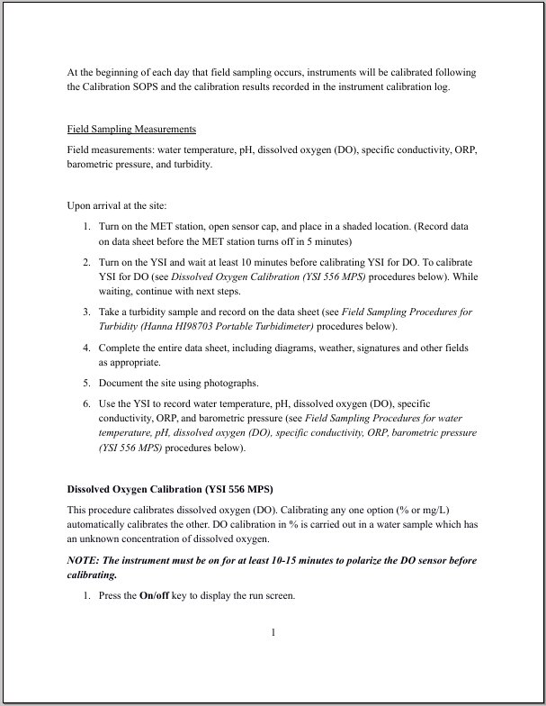
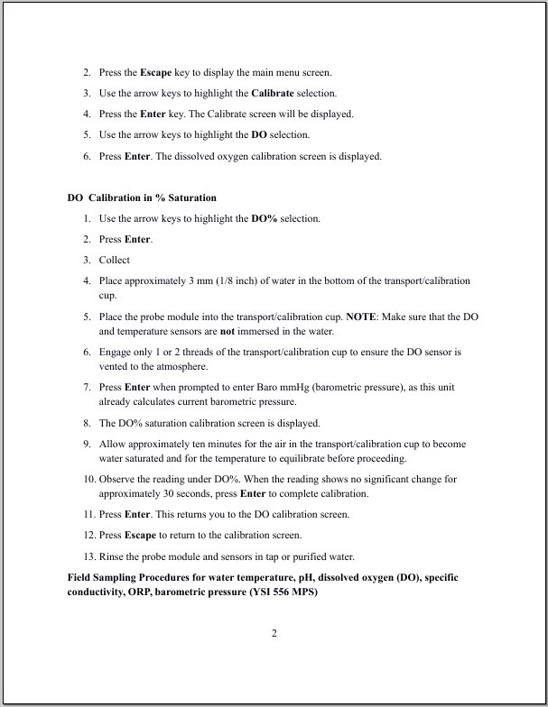

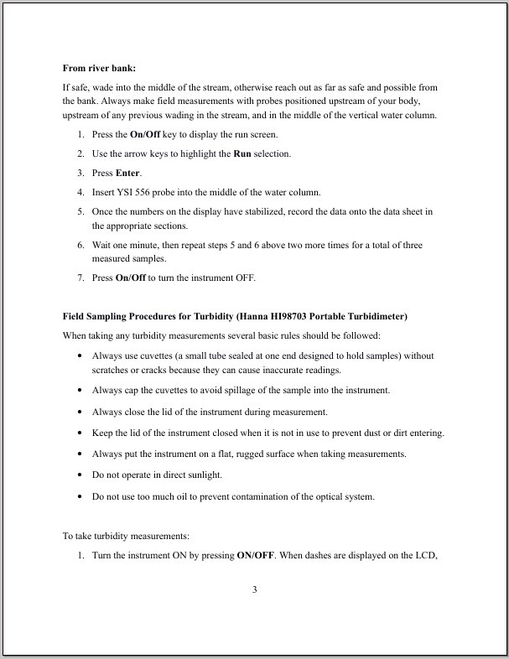

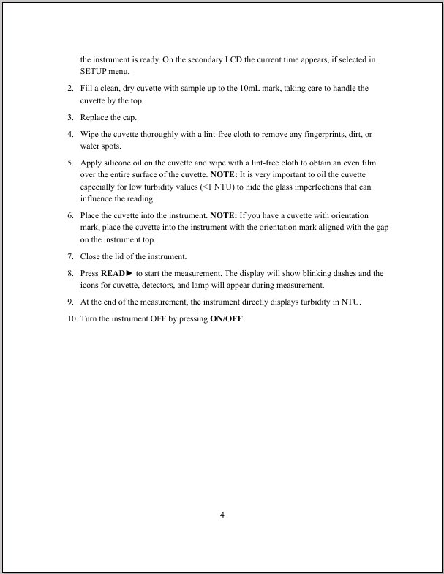

C.2 Calibration

C.2.1 Hanna HI98703 Portable Turbidimeter

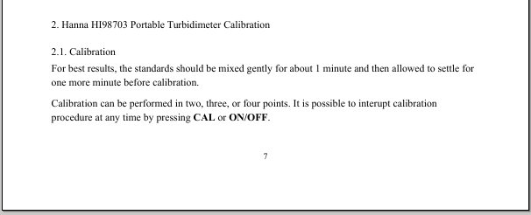

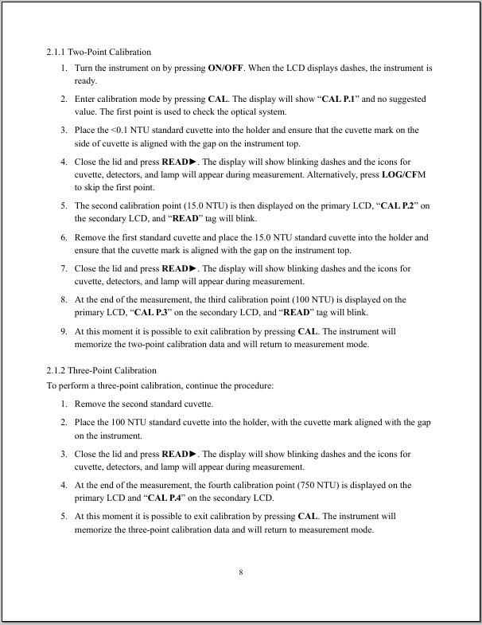
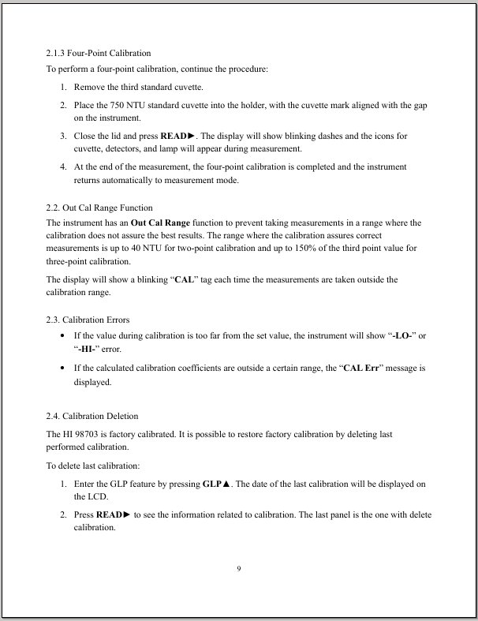
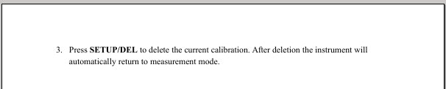

C.2.2 YSI Multi Probe System
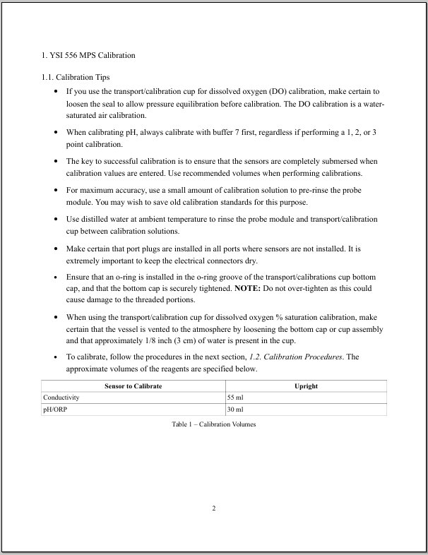
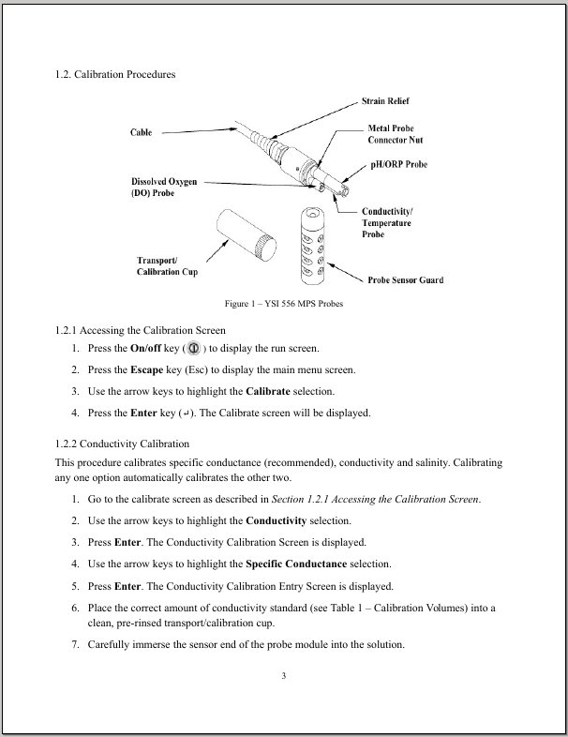
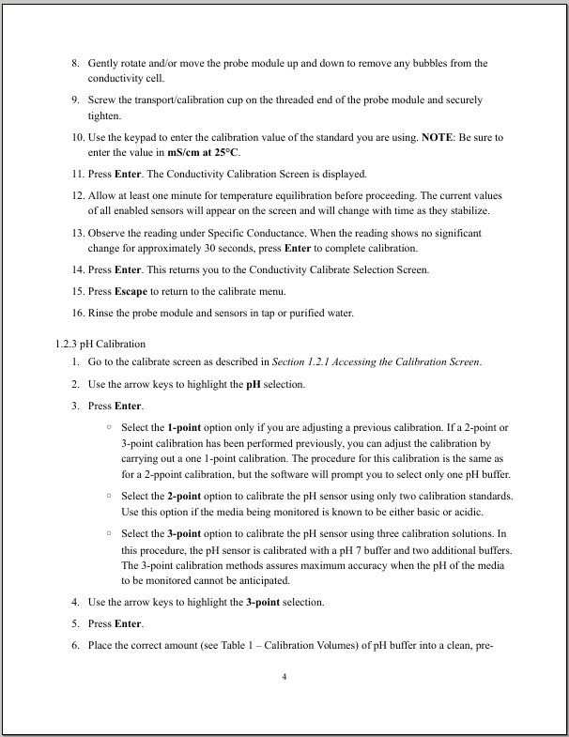
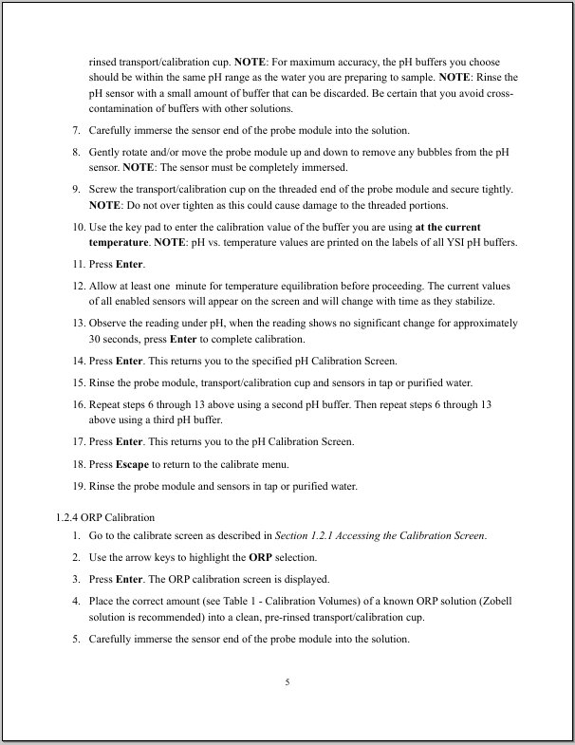
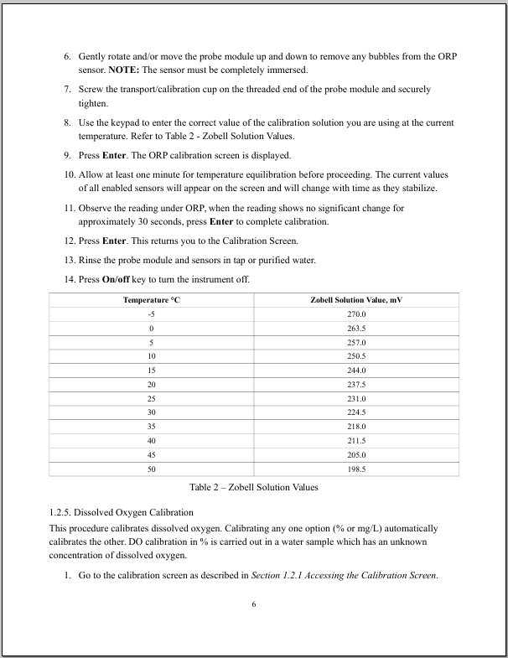
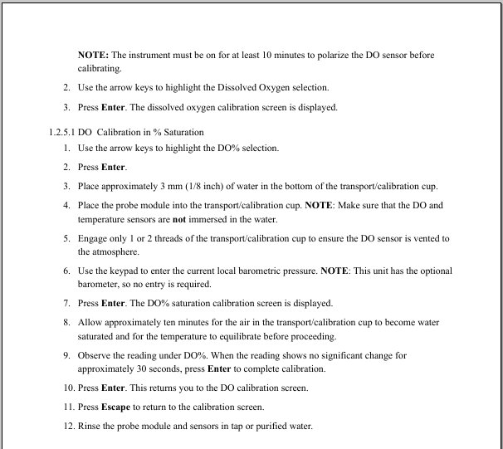

Appendix D: Forms

D.1 Inspection Datasheet
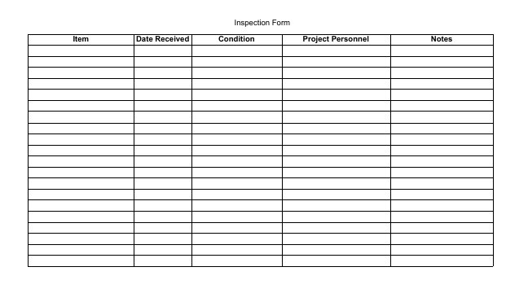

D.2 Sample Collection Datasheet
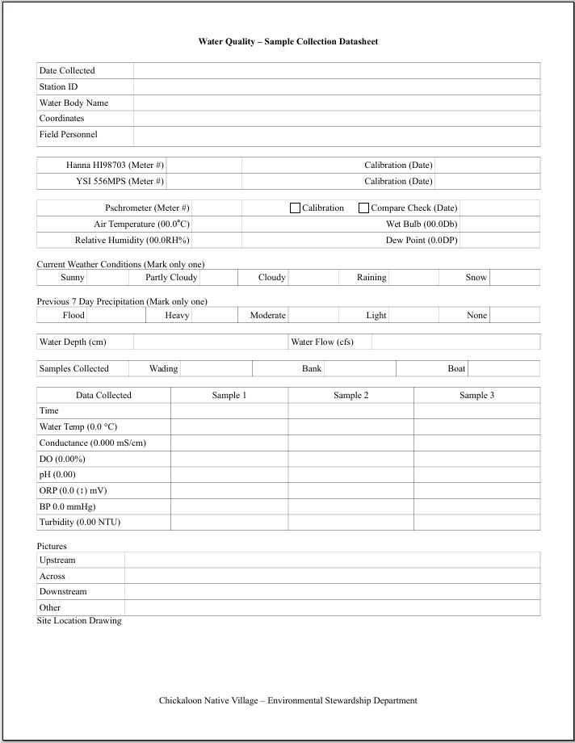

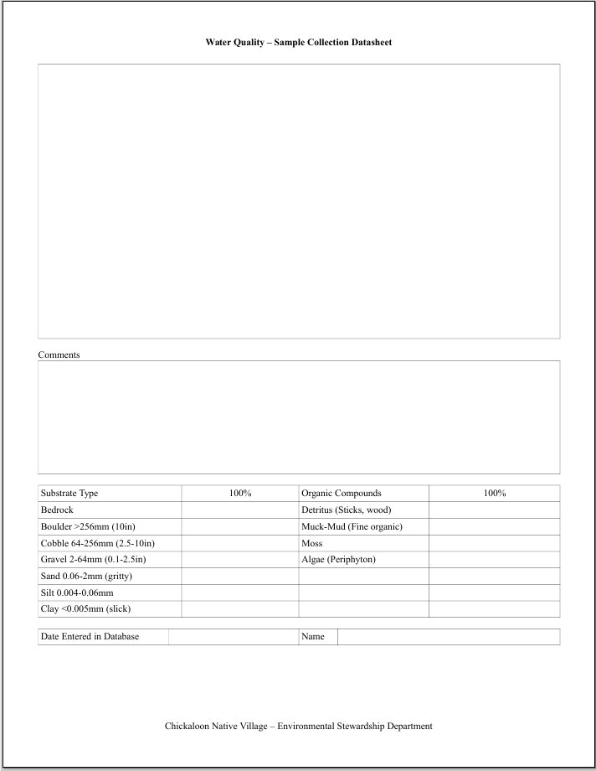

D.3 Equipment Calibration Sheets

D.3.1 Hanna HI98703 Portable Turbidimeter

D.3.2 YSI Multi Probe System
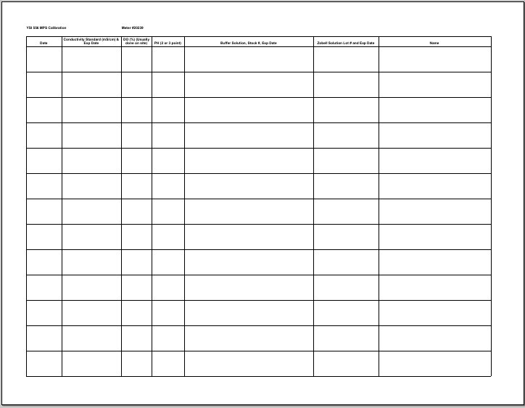

D.4 Corrective Action Form

D.5 Sample Alteration Form

Appendix E: Sampling Stations

E.1 Sampling Stations List
Station ID | Name | Latitude | Longitude
MC001 | Moose Creek Upper | 61.731624 | -149.029374
MC002 | Moose Creek Lower | 61.681437 | -149.047222
EC001 | Eska Creek | 61.710221 | -148.896713
GC001 | Granite Creek | 61.711493 | -148.853654
KR001 | Kings River | 61.732685 | -148.747012
CR001 | Chickaloon River | 61.785216 | -148.455979
PC001 | Purinton Creek | 61.810454 | -148.135920
CC001 | Caribou Creek | 61.802677 | -147.682130
WC001 | Wolverine Creek | 61.655762 | -149.029733
CAC001 | California Creek | 61.795882 | -148.479551
BC001 | Buffalo Creek | 61.724650 | -149.032825
WW001 | Wishbone Hill Wetlands | 61.733623 | -149.026947
*Coordinates are in decimal degrees using NAD83 UTM Zone 6N

E.2 Map of Sampling Stations Locations
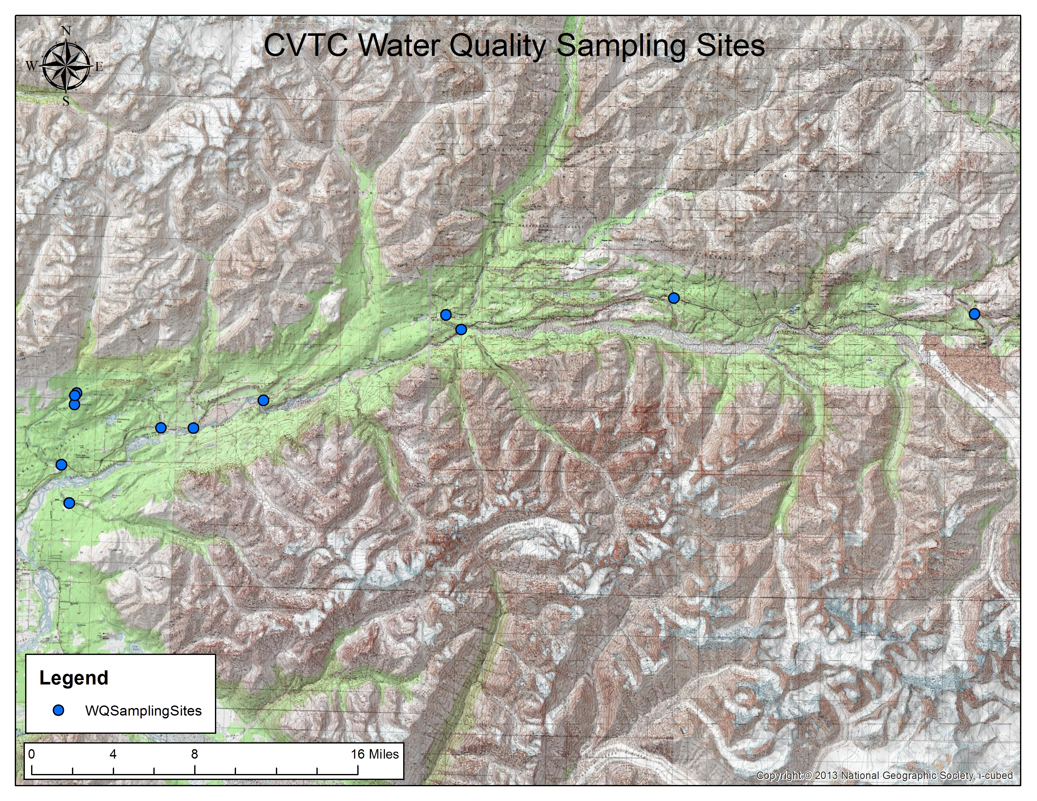

Appendix F: Data Quality Objectives Summary Table
Parameter | Analytical Method | Range | Units | Resolution | Accuracy | Relative Percent Difference (RPD) | Sample Preservation & Storage
pH | YSI 556MPS  Glass Combination Electrode | 0 to 14 units | Standard pH units | 0.01 units | ±0.2 units | 10% | Analyze immediately
Dissolved Oxygen % | YSI 556MPS  Steady state polarographic | 0 to 500% | % air saturation | 0.1% | ±2% | 10% | Analyze immediately
Temperature | YSI 556MPS  YSI Temperature Precision thermistor | -5 to 45°C | Degrees Celsius | 0.1°C | ±0.15°C | 5% | Analyze immediately
Conductivity | YSI 556MPS  4-electrode cell with autoranging | 0 to 200mS/cm | Milli-Siemens/cm | 0.001mS/cm to 0.1mS/cm | ±0.5% | 10% | Analyze immediately
ORP | YSI 556MPS  Platinum button | -999 to +999mV | Milli-Volts | 0.1mV | ±20mV |  | Analyze immediately
Barometric Pressure | YSI 556MPS | 500 to 800mmHg | Millimeter of Mercury | 0.1mmHg | ±3mmHg within ±10°C temperature range from calibration point |  | Analyze immediately
Turbidity | HI98703  Ratio Nephelometric signal (90') scatter light ratio transmitted light | 0.00 to 9.99 NTU  10.0 to 99.9 NTU  100 to 1000 NTU | Nephelometric Turbidity Unit | 0.01NTU from 0.00 to 9.99 NTU  0.1NTU from 10.0 to 99.9 NTU  1NTU from 100 to 1000 NTU | ±2% plus 0.02NTU | 10% | Analyze immediately

Appendix G: Sampling Frequency Table
Parameter | Months* | Days*
pH | April through October | 2 per month
pH | November through March | 1 per month
Dissolved Oxygen | April through October | 2 per month
Dissolved Oxygen | November through March | 1 per month
Temperature | April through October | 2 per month
Temperature | November through March | 1 per month
Conductivity | April through October | 2 per month
Conductivity | November through March | 1 per month
ORP | April through October | 2 per month
ORP | November through March | 1 per month
Barometric Pressure | April through October | 2 per month
Barometric Pressure | November through March | 1 per month
Turbidity | April through October | 2 per month
Turbidity | November through March | 1 per month
* Personnel will strive to maintain a regular monitoring schedule as the weather allows. More sample may be collected if time and funding allows.

